**Segmenting and Clustering Neighborhoods in Fredericton, NB**

# Applied Data Science Capstone Week 5 Peer-Graded Project Report

# Introduction to the opportunity

Fredericton is the Capital City of the only Canadian fully-bilingual Province of New Brunswick and is beautifully located on the banks of the Saint John River. While one of the least populated provincial capital cities with a population base of less than 60 thousand residents, it offers a wide spectrum of venues and is a governement, university and cultural hub.

As the city grows and develops, it becomes increasingly important to examine and understand it quantitiatively. The City of Fredericton provides open data for everyone and encourages entrepreneurial use to develop services for the benefit of its ciitzens.

Developers, investors, policy makers and/or city planners have an interest in answering the following questions as the need for additional services and citizen protection:

1. What neighbourhoods have the highest crime? 2. Is population density correlated to crime level?

1. Using Foursquare data, what venues are most common in different locations within the city?
2. Does the Knowledge Park really need a coffee shop?

Does the Open Data project have specific enough or thick enough data to empower decisions to be made or is it too aggregate to provide value in its current detail? Let's find out.

# Data

To understand and explore we will need the following City of Fredericton Open Data:

In [73]:

**from**

**IPython.display**

**import**

Image

**from**

**IPython.core.display**

**import**

HTML

Image

(

url

=

"http://www.tourismfredericton.ca/sites/default/files/field/image/freder

icton.jpg"

)

Out[73]:

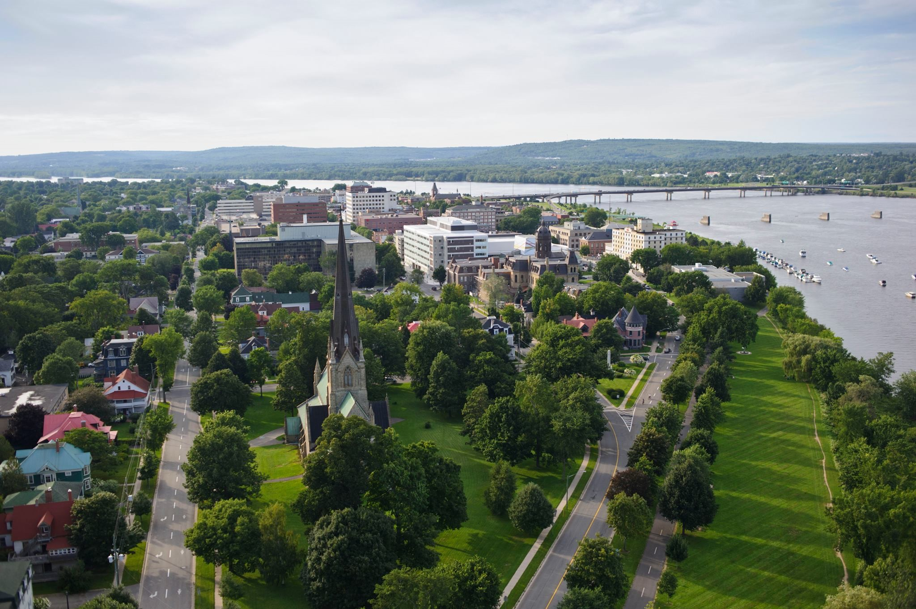

1. Open Data Site: [http://data-fredericton.opendata.arcgis.com/ (http://data-fredericton.opendata.arcgis.com/)](http://data-fredericton.opendata.arcgis.com/)
2. [Fredericton Neighbourhoods: http://data-fredericton.opendata.arcgis.com/datasets/neighbourhoods--quartiers](http://data-fredericton.opendata.arcgis.com/datasets/neighbourhoods--quartiers)

[(http://data-fredericton.opendata.arcgis.com/datasets/neighbourhoods--quartiers)](http://data-fredericton.opendata.arcgis.com/datasets/neighbourhoods--quartiers)

1. [Fredericton Crime by Neighbourhood: http://data-fredericton.opendata.arcgis.com/datasets/crime-by-neighbourhood2017--crime-par-quartier-2017 (http://data-fredericton.opendata.arcgis.com/datasets/crime-by-neighbourhood-2017-crime-par-quartier-2017)](http://data-fredericton.opendata.arcgis.com/datasets/crime-by-neighbourhood-2017--crime-par-quartier-2017)
2. [Fredericton Census Tract Demographics: http://data-fredericton.opendata.arcgis.com/datasets/census-tractdemographics--donn%C3%A9es-d%C3%A9mographiques-du-secteur-de-recensement (http://data-](http://data-fredericton.opendata.arcgis.com/datasets/census-tract-demographics--donn%C3%A9es-d%C3%A9mographiques-du-secteur-de-recensement)

[fredericton.opendata.arcgis.com/datasets/census-tract-demographics--donn%C3%A9es-d%C3%A9mographiques-dusecteur-de-recensement)](http://data-fredericton.opendata.arcgis.com/datasets/census-tract-demographics--donn%C3%A9es-d%C3%A9mographiques-du-secteur-de-recensement)

1. [Fredericton locations of interest: https://github.com/JasonLUrquhart/Applied-Data-Science-](https://github.com/JasonLUrquhart/Applied-Data-Science-Capstone/blob/master/Fredericton%20Locations.xlsx)

[Capstone/blob/master/Fredericton%20Locations.xlsx (https://github.com/JasonLUrquhart/Applied-Data-ScienceCapstone/blob/master/Fredericton%20Locations.xlsx)](https://github.com/JasonLUrquhart/Applied-Data-Science-Capstone/blob/master/Fredericton%20Locations.xlsx)

1. Foursquare Developers Access to venue data: [https://foursquare.com/ (https://foursquare.com/)](https://foursquare.com/)

Using this data will allow exploration and examination to answer the questions. The neighbourhood data will enable us to properly group crime by neighbourhood. The Census data will enable us to then compare the population density to examine if areas of highest crime are also most densely populated. Fredericton locations of interest will then allow us to cluster and quantitatively understand the venues most common to that location.

**Methodology**

All steps are referenced beleow in the Appendix: Analysis section.

The methodology will include:

1. Loading each data set
2. Examine the crime frequency by neighbourhood
3. Study the crime types and then pivot analysis of crime type frequency by neighbourhood
4. Understand correlation between crimes and population density
5. Perform k-means statisical analysis on venues by locations of interest based on findings from crimes and neighbourhood
6. Determine which venues are most common statistically in the region of greatest crime count then in all other locations of interest.
7. Determine if an area, such as the Knowledge Park needs a coffee shop.

## Loading the data

After loading the applicable libraries, the referenced geojson neighbourhood data was loaded from the City of Fredericton

Open Data site. This dataset uses block polygon shape coordinates which are better for visualization and comparison. The City also uses Ward data but the Neighbourhood location data is more accurate and includes more details. The same type of dataset was then loaded for the population density from the Stats Canada Census tracts.

The third dataset, an excel file, "Crime by Neighbourhood 2017" downloaded from the City of Fredericton Open Data site is found under the Public Safety domain. This dataset was then uploaded for the analysis. It's interesting to note the details of this dataset are aggregated by neighbourhood. It is not an exhaustive set by not including all crimes (violent offenses) nor specific location data of the crime but is referenced by neighbourhood.

This means we can gain an understanding of the crime volume by type by area but not specific enough to understand the distribution properties. Valuable questions such as, "are these crimes occuring more often in a specific area and at a certain time by a specific demographic of people?" cannot be answered nor explored due to what is reasonably assumed to be personal and private information with associated legal risks.

There is value to the city to explore the detailed crime data using data science to predict frequency, location, timing and conditions to best allocated resources for the benefit of its citizens and it's police force. However, human behaviour is complex requiring thick profile data by individual and the conditions surrounding the event(s). To be sufficient for reliable future prediction it would need to demonstrate validity, currency, reliability and sufficiency.

## Exploring the data

Exploring the count of crimes by neighbourhood gives us the first glimpse into the distribution.

One note is the possibility neighbourhoods names could change at different times. The crime dataset did not mention which specific neighbourhood naming dataset it was using but we assumed the neighbourhood data provided aligned with the neighbourhoods used in the crime data. It may be beneficial for the City to note and timestamp neighbourhood naming in the future or simply reference with neighbourhood naming file it used for the crime dataset.

An example of data errors: There was an error found in the naming of the neighbourhood "Platt". The neighbourhood data stated "Plat" while the crime data stated "Platt". Given the crime dataset was most simple to manipulate it was modified to "Plat". The true name of the neighbourhood is "Platt".

### First Visualization of Crime

Once the data was prepared, a choropleth map was created to view the crime count by neighbourhood. As expected the region of greatest crime count was found in the downtown and Platt neighbourhoods.

Examining the crime types enables us to learn the most frequent occuring crimes which we then plot as a bar chart to see most frequenty type.

Theft from motor vehicles is most prevalent in the same area as the most frequent crimes. It's interesting to note this area is mostly residential and most do not have garages. It would be interesting to further examine if surveillance is a deterant for motor vehicle crimes in the downtown core compared to low surveillance in the Platt neighbourhood.

### Examining 2nd most common crime given it is specific: theft from vehicles

After exploring the pivot table showing Crime_Type by Neighbourhood, we drill into a specific type of crime, theft from vehicles and plot the choropleth map to see which area has the greatest frequency.

Again, the Platt neighbourhood appears as the most frequent.

Is this due to population density?

### Introducing the Census data to explore the correlation between crime frequency and population density.

Visualising the population density enables us to determine that the Platt neighbourhood has lower correlation to crime frequency than I would have expected.

It would be interesting to further study the Census data and if this captures the population that is renting or more temporary/transient poplution, given the City is a University hub.

## Look at specific locations to understand the connection to venues using Foursquare data

Loading the "Fredericton Locations" data enables us to perform a statistical analysis on the most common venues by location.

We might wonder if the prevalence of bars and clubs in the downtown region has something to do with the higher crime rate in the near Platt region.

Plotting the latitude and longitude coordinates of the locations of interest onto the crime choropleth map enables us to now study the most common venues by using the Foursquare data.

### Analysing each Location

Grouping rows by location and the mean of the frequency of occurance of each category we venue categories we study the top five most common venues.

Putting this data into a pandas dataframe we can then determine the most common venues by location and plot onto a map.

# Results

The analysis enabled us to discover and describe visually and quantitatively:

1. Neighbourhoods in Fredericton
2. Crime freqency by neighbourhood
3. Crime type frequency and statistics. The mean crime count in the City of Fredericton is 22.
4. Crime type count by neighbourhood.

Theft from motor vehicles is most prevalent in the same area as the most frequent crimes. It's interesting to note this area is mostly residential and most do not have garages. It would be interesting to further examine if surveillance is a deterant for motor vehicle crimes in the downtown core compared to low surveillance in the Platt neighbourhood.

1. Motor Vehicle crimes less than $5000 analysis by neighbourhood and resulting statistics.

The most common crime is **Other Theft less than 5k** followed by **Motor Vehicle Theft less than 5k**. There is a mean of 6 motor vehicle thefts less than 5k by neighbourhood in the City.

1. That population density and resulting visual correlation is not strongly correlated to crime frequency. Causation for crime is not able to be determined given lack of open data specificity by individual and environment.
2. Using k-menas, we were able to determine the top 10 most common venues within a 1 km radius of the centroid of the highest crime neighbourhood. **The most common venues in the highest crime neighbourhood are coffee shops followed by Pubs and Bars**.

While, it is not valid, consistent, reliable or sufficient to assume a higher concentration of the combination of coffee shops, bars and clubs predicts the amount of crime occurance in the City of Fredericton, this may be a part of the model needed to be able to in the future.

1. We were able to determine the top 10 most common venues by location of interest.
2. Statisically, we determined there are no coffee shops within the Knowledge Park clusters.

# Discussion and Recommendations

The City of Fredericton Open Data enables us to gain an understanding of the crime volume by type by area but not specific enough to understand the distribution properties. Valuable questions such as, "are these crimes occuring more often in a specific area and at a certain time by a specific demographic of people?" cannot be answered nor explored due to what is reasonably assumed to be personal and private information with associated legal risks.

There is value to the city to explore the detailed crime data using data science to predict frequency, location, timing and conditions to best allocated resources for the benefit of its citizens and it's police force. However, human behaviour is complex requiring thick profile data by individual and the conditions surrounding the event(s). To be sufficient for reliable future prediction it would need to demonstrate validity, currency, reliability and sufficiency.

A note of caution is the possibility neighbourhoods names could change. The crime dataset did not mention which specific neighbourhood naming dataset it was using but we assumed the neighbourhood data provided aligned with the neighbourhoods used in the crime data. It may be beneficial for the City to note and timestamp neighbourhood naming in the future or simply reference with neighbourhood naming file it used for the crime dataset.

Errors exist in the current open data. An error was found in the naming of the neighbourhood "Platt". The neighbourhood data stated "Plat" while the crime data stated "Platt". Given the crime dataset was most simple to manipulate it was modified to "Plat". The true name of the neighbourhood is "Platt".

Theft from motor vehicles is most prevalent in the same area as the most frequent crimes. It is interesting to note this area is mostly residential and most do not have garages. It would be interesting to further examine if surveillance is a deterant for motor vehicle crimes in the downtown core compared to low surveillance in the Platt neighbourhood.

It would be interesting to further study the Census data and if this captures the population that is renting or more temporary/transient poplution, given the City is a University hub.

Given the findings of the top 10 most frequent venues by locations of interest, the Knowledge Park does not have Coffee Shops in the top 10 most common venues as determined from the Foursquare dataset. Given this area has the greatest concentration of stores and shops as venues, it would be safe to assume a coffee shop would be beneficial to the business community and the citizens of Fredericton.

# Conclusion

Using a combination of datasets from the City of Fredericton Open Data project and Foursquare venue data we were able to analyse, discover and describe neighbhourhoods, crime, population density and statistically describe quantitatively venues by locations of interest.

While overall, the City of Fredericton Open Data is interesting, it misses the details required for true valued quantitiatve analysis and predictive analytics which would be most valued by investors and developers to make appropriate investments and to minimize risk.

The Open Data project is a great start and empowers the need for a "Citizens Like Me" model to be developed where citizens of digital Fredericton are able to share their data as they wish for detailed analysis that enables the creation of valued services.

**APPENDIX: Analysis**

## Load Libraries

In [74]:

**import**

**numpy**

**as**

**np**

*# library to handle data in a vectorized manner*

**import**

**pandas**

**as**

**pd**

*# library for data analysis*

pd

.

set_option

(

'display.max_columns'

,

**None**

)

pd

.

set_option

(

'display.max_rows'

,

**None**

)

**import**

**json**

*# library to handle JSON files*

!

conda install -c conda-forge geopy --yes # uncomment this line

**if**

you haven

'

t comp

leted the Foursquare API lab

**from**

**geopy.geocoders**

**import**

Nominatim

*# convert an address into latitude and longit*

*ude values*

**import**

**requests**

*# library to handle requests*

**from**

**pandas.io.json**

**import**

json_normalize

*# tranform JSON file into a pandas datafr*

*ame*

*# Matplotlib and associated plotting modules*

**import**

**matplotlib.cm**

**as**

**cm**

**import**

**matplotlib.colors**

**as**

**colors**

*# import k-means from clustering stage*

**from**

**sklearn.cluster**

**import**

KMeans

*# for webscraping import Beautiful Soup*

**from**

**bs4**

**import**

BeautifulSoup

**import**

**xml**

!

conda install -c conda-forge

folium

=

0

.5.0 --

yes

**import**

**folium**

*# map rendering library*

print

(

'Libraries imported.'

)

Solving environment: done

# All requested packages already installed.

Solving environment: done

# All requested packages already installed.

Libraries imported.

In [3]:pwd

Out[3]: '/Users/jasonkristaurquhart/Documents/GitHub/Coursera-IBM-Applied-Data-Science-Cap stone-Project'

In [75]:

r

=

requests

.

get

(

'https://opendata.arcgis.com/datasets/823d86e17a6d47808c6e4f1c2dd9

7928_0

.geojson'

)

fredericton_geo

=

r

.

json

()

In [76]:

neighborhoods_data

=

fredericton_geo

[

'features'

]

In [77]:

neighborhoods_data

[

0

]

Out[77]: {'type': 'Feature',

'properties': {'FID': 1,

'OBJECTID': 1,

'Neighbourh': 'Fredericton South',

'Shape_Leng': 40412.2767429,

'Shape_Area': 32431889.0002},

'geometry': {'type': 'Polygon',

'coordinates': [[[-66.6193489311946, 45.8688925859664],

[-66.5986068312843, 45.8934317575498],

[-66.5998465063764, 45.8962889533894],

[-66.6005561754508, 45.8987959122414],

[-66.6007627879662, 45.9004150599189],

[-66.6005112596866, 45.9020341603803],

[-66.5993703992758, 45.9049409211054],

[-66.5983912356161, 45.9066536507875],

[-66.5950405196063, 45.9110977503182],

[-66.5924713378938, 45.9137165396725],

[-66.5975198697905, 45.9151915074375],

[-66.6016161874861, 45.9165914405789],

[-66.6063862416448, 45.9184662957134],

[-66.6102310310608, 45.9201848572716],

[-66.6193938469588, 45.9264149777787],

[-66.6194297795702, 45.9243466803461],

[-66.6206694546623, 45.9221345790227],

[-66.6241459348118, 45.9181100781124],

[-66.6249634017204, 45.9177976046497], [-66.6258796833102, 45.917910095299],

[-66.6292124330143, 45.9200348758374],

[-66.632733828928, 45.9225720071846],

[-66.6356353872957, 45.924409167803],

[-66.6362731911474, 45.9249840491044],

[-66.6381955858555, 45.9258900999313],

[-66.6400281490351, 45.9272147820915],

[-66.6469721261813, 45.9309512150791],

[-66.6492628301558, 45.9324257247173],

[-66.6501521622871, 45.9331254782868],

[-66.6504306400252, 45.9337564984884],

[-66.6505653873178, 45.9347436246005],

[-66.6503587748024, 45.9357182382069],

[-66.6520745569951, 45.9352246860213],

[-66.6532513500173, 45.9350872403269],

[-66.6541855979128, 45.9351122304785],

[-66.6557756159657, 45.9353808738969],

[-66.6597461695215, 45.9365616400027],

[-66.6692323789218, 45.9408659130747],

[-66.6702205257343, 45.9411720097543],

[-66.6705888350008, 45.9415718069541],

[-66.6717027459531, 45.9418654061867],

[-66.6805601346545, 45.9456570693391],

[-66.6808206460869, 45.945613344883],

[-66.690998558256, 45.9498794400526],

[-66.6932353633134, 45.9503791076107],

[-66.6956697977334, 45.9504478115476],

[-66.6955530167465, 45.9498607024316],

[-66.695014027576, 45.9498607024316],

[-66.6956248819692, 45.948261735435],

[-66.699766115429, 45.9452510552052],

[-66.6993978061625, 45.9450511702315],

[-66.6996762839006, 45.9448512845371],

[-66.6992271262585, 45.9446139193389],

[-66.7022364824603, 45.9407722096716],

[-66.7041049782513, 45.9393666396225],

[-66.7046080348104, 45.9387919073835],

[-66.7061441539463, 45.9390980155132],

[-66.7051919397451, 45.9388543785676],

[-66.7056949963042, 45.937405028971],

[-66.706611277894, 45.9362430230541],

[-66.7074107784969, 45.9356745059121],

[-66.7087133356588, 45.9350435075345],

[-66.7110938711618, 45.9342063302882],

[-66.7122526978783, 45.9309262230525],

[-66.7096026677901, 45.9293891917718],

[-66.6746402369322, 45.9061285859908],

[-66.6193489311946, 45.8688925859664]],

[[-66.6934150263703, 45.938648223393],

[-66.7001973067654, 45.9422339647247],

[-66.6939180829294, 45.9467626619838],

[-66.6912141539242, 45.9449262417569],

[-66.6899475293736, 45.9445014828376],

[-66.6890312477838, 45.9444702504357],

[-66.6889683657139, 45.9443827996167],

[-66.6899565125264, 45.9418404190785],

[-66.6934150263703, 45.938648223393]],

[[-66.6550120479742, 45.9291455121693],

[-66.6557756159657, 45.9292704762017],

[-66.6599797314954, 45.9309387190672],

[-66.6629172224744, 45.9322757763752], [-66.6631867170597, 45.932475707408],

[-66.6631238349898, 45.9327880982037],

[-66.6619290756619, 45.9341813397283],

[-66.6616146653125, 45.9340751297235], [-66.6601863440107, 45.934818595486],

[-66.6591442982811, 45.9350997354041],

[-66.6586053091106, 45.9351059829416],

[-66.6564673187345, 45.9348748235837],

[-66.6542933957469, 45.9340501391045],

[-66.6529908385849, 45.9333129107794],

[-66.652308118969, 45.9324569639043],

[-66.652191337982, 45.9319696305845],

[-66.6522721863576, 45.9313573339335],

[-66.6520476075366, 45.9305825815444],

[-66.6521284559121, 45.9301264722544],

[-66.6524428662616, 45.9296016295261],

[-66.6531166027247, 45.9293392062996],

[-66.6540508506202, 45.9291580085852],

[-66.6550120479742, 45.9291455121693]],

[[-66.6318085641854, 45.8878357293373],

[-66.6328775593735, 45.8879357750148],

[-66.6341801165354, 45.8882108996987],

[-66.6351502970423, 45.8885422980769],

[-66.6362462416889, 45.8890987927924],

[-66.6370098096804, 45.8896365239624],

[-66.6381596532441, 45.8909183040123],

[-66.6385818614276, 45.8918186586532],

[-66.6387435581788, 45.8925689430378],

[-66.6385908445805, 45.8940757335582],

[-66.6327517952337, 45.900733882662],

[-66.62923039932, 45.9050971942525],

[-66.6276673307256, 45.9064848805016], [-66.626454605092, 45.9071974626627],

[-66.6253856099039, 45.9076662617274],

[-66.6230230407067, 45.9082913209882],

[-66.6205077579111, 45.9084913384651],

[-66.6180014582685, 45.9082413165064],

[-66.6181092561025, 45.9082100636823],

[-66.6170312777616, 45.9076037554142],

[-66.6161239793246, 45.9068661756028],

[-66.6150909167479, 45.9054972515047],

[-66.6147944727041, 45.9047533927481],

[-66.6146417591058, 45.9037907372083],

[-66.6146956580229, 45.9030155998367],

[-66.614974135761, 45.9020654166814],

[-66.617345688111, 45.8989772091164],

[-66.6203819937714, 45.8954199312614],

[-66.6263468072579, 45.8892363524244],

[-66.6281254715205, 45.8883672199348],

[-66.6291315846387, 45.8880795903605],

[-66.6304521081064, 45.8878732464875],

[-66.6318085641854, 45.8878357293373]]]}}

In [78]:

g

=

requests

.

get

(

'https://opendata.arcgis.com/datasets/6179d35eacb144a5b5fdcc869f86

dfb5_0.geojson'

)

demog_geo

=

g

.

json

()

In [79]:

demog_data

=

demog_geo

[

'features'

]

demog_data

[

0

]

Out[79]:

{

'type': 'Feature',

'properties': {'FID': 1,

'OBJECTID': 501,

'DBUID': '1310024304',

'DAUID': '13100243',

'CDUID': '1310',

'CTUID': '3200002.00',

'CTNAME': '0002.00',

'DBuid_1': '1310024304',

'DBpop2011': 60,

'DBtdwell20': 25,

'DBurdwell2': 22,

'Shape_Leng': 0.00746165241824,

'Shape_Area': 2.81310751889e-06,

'CTIDLINK': 3200002,

'Shape__Area': 2.81310897700361e-06,

'Shape__Length': 0.00746165464503067},

'geometry': {'type': 'Polygon',

'coordinates': [[[-66.634784212921, 45.9519239912381],

[-66.6351046935752, 45.9507605156138],

[-66.6378263667982, 45.9510868696778],

[-66.636944377136, 45.9521037018384],

[-66.634784212921, 45.9519239912381]]]}}

In [ ]:

11

In [80]:

**import**

**os**

os

.

listdir

(

'.'

)

Out[80]: ['Capstone Project Course.ipynb',

'Fredericton_Census_Tract_Demographics.csv',

'.DS_Store',

'Fredericton_Census_Tract_Demographics.xlsx',

'Crime_by_neighbourhood_2017.xlsx',

'Capstone Fredericton Crime and Police Station Location.ipynb',

'Boston_Neighborhoods (1).geojson',

'Fredericton Locations.xlsx',

'Week 3 Capstone - Segmenting and Clustering Neighbourhoods in Toronto_Part 2.ipy nb',

'Fredericton.jpg',

'Week 3 Capstone - Segmenting and Clustering Neighbourhoods in Toronto_Part 2.pd f',

'Boston_Neighborhoods.geojson',

'.ipynb_checkpoints',

'.git',

'Week 3 Capstone - Segmenting and Clustering Neighbourhoods in Toronto.ipynb',

'Week 4 Capstone - Segmenting and Clustering Neighbourhoods in Boston.ipynb', 'Week 3 Capstone - Segmenting and Clustering Neighbourhoods in Toronto_Part 2.ht m',

'Week 4 Capstone - Segmenting and Clustering Neighbourhoods in Fredericton.ipyn b',

'Week 4 Capstone - Segmenting and Clustering Neighbourhoods in Fredericton - Gith ub submit.ipynb',

'Week 3 Capstone - Segmenting and Clustering Neighbourhoods in Toronto_Part 2_fil es']

In [81]:

opencrime

=

'Crime_by_neighbourhood_2017.xlsx'

In [82]:

workbook

=

pd

.

ExcelFile

(

opencrime

)

print

(

workbook

.

sheet_names

)

[

'Crime_by_neighbourhood_2017'

]

In [83]:

crime_df

=

workbook

.

parse

(

'Crime_by_neighbourhood_2017'

)

crime_df

.

head

()

Out[83]:

**Neighbourhood From_Date To_Date Crime_Code Crime_Type Ward City FID**

1. FredeSrioctuotnh 05T00:002:0001.70-0001Z- 26T00:002:0001.70-0001Z- 2120 RBE&SEI DNNOCNE- 7 Fredericton 1
2. FredeSrioctuotnh 04T00:002:0001.70-0003Z- 06T00:002:0001.70-0003Z- 2120 RBE&SEI DNNOCNE- 7 Fredericton 2
3. FredeSrioctuotnh 07T00:002:0001.70-0005Z- NaN 2120 RBE&SEI DNNOCNE- 12 Fredericton 3
4. FredeSrioctuotnh 20T00:002:0001.70-0006Z- 21T00:002:0001.70-0006Z- 2120 RBE&SEI DNNOCNE- 12 Fredericton 4
5. FredeSrioctuotnh 09T00:002:0001.70-0007Z- 10T00:002:0001.70-0007Z- 2120 RBE&SEI DNNOCNE- 7 Fredericton 5

In [84]: crime_df.drop(['From_Date', 'To_Date'], axis=1,inplace=**True**)

# What is the crime count by neighbourhood?

In [128]:

crime_data

=

crime_df

.

groupby

([

'Neighbourhood'

])

.

size

()

.

to_frame

(

name

=

'Count'

)

.

rese

t_index

()

crime_data

Out[128]:

**Neighbourhood Count**

1. Barkers Point 47
2. Brookside 54
3. Brookside Estates 9
4. Brookside Mini Home Park 5
5. College Hill 41
6. Colonial heights 9
7. Cotton Mill Creek 4
8. Diamond Street 1
9. Doak Road 1
10. Douglas 3
11. Downtown 127
12. Dun's Crossing 18
13. Forest Hill 12
14. Fredericton South 85
15. Fulton Heights 36
16. Garden Creek 13
17. Garden Place 4
18. Gilridge Estates 3
19. Golf Club 7
20. Grasse Circle 1
21. Greenwood Minihome Park 2
22. Hanwell North 8 **22** Heron Springs 3
23. Highpoint Ridge 5
24. Kelly's Court Minihome Park 1
25. Knob Hill 4
26. Knowledge Park 1 **27** Lian / Valcore 7
27. Lincoln 13
28. Lincoln Heights 14
29. Main Street 78
30. Marysville 39
31. McKnight 4
32. McLeod Hill 3
33. Monteith / Talisman 12
34. Montogomery / Prospect East 16
35. Nashwaaksis 25
36. Nethervue Minihome Park 1
37. North Devon 113

**Neighbourhood Count**

1. Northbrook Heights 10
2. Plat 198
3. Poet's Hill 4
4. Prospect 81 **43** Rail Side 3
5. Regiment Creek 1
6. Royal Road 7
7. Saint Mary's First Nation 25
8. Saint Thomas University 1
9. Sandyville 9
10. Serenity Lane 2
11. Shadowood Estates 5
12. Silverwood 12
13. Skyline Acrea 27
14. South Devon 68
15. Southwood Park 16
16. Springhill 1
17. Sunshine Gardens 10
18. The Hill 44
19. The Hugh John Flemming Forestry Center 3
20. University Of New Brunswick 15
21. Waterloo Row 9
22. Wesbett / Case 1
23. West Hills 5
24. Williams / Hawkins Area 17
25. Woodstock Road 41
26. Youngs Crossing 16

In [153]:

crime_data

.

describe

()

Out[153]:

**Count**

**count** 66.000000 **mean** 22.121212 **std** 34.879359 **min** 1.000000 **25%** 3.000000 **50%** 9.000000 **75%** 23.250000 **max** 198.000000

In [86]:

crime_data

.

rename

(

index

=

str

,

columns

=

{

'Neighbourhood'

:

'Neighbourh'

,

'Count'

:

'Crime_C

ount'

}

,

inplace

=

**True**

)

crime_data

Out[86]:

**Neighbourh Crime_Count**

1. Barkers Point 47
2. Brookside 54
3. Brookside Estates 9
4. Brookside Mini Home Park 5
5. College Hill 41
6. Colonial heights 9
7. Cotton Mill Creek 4
8. Diamond Street 1
9. Doak Road 1
10. Douglas 3
11. Downtown 127
12. Dun's Crossing 18
13. Forest Hill 12
14. Fredericton South 85
15. Fulton Heights 36
16. Garden Creek 13
17. Garden Place 4
18. Gilridge Estates 3
19. Golf Club 7
20. Grasse Circle 1
21. Greenwood Minihome Park 2
22. Hanwell North 8 **22** Heron Springs 3
23. Highpoint Ridge 5
24. Kelly's Court Minihome Park 1
25. Knob Hill 4
26. Knowledge Park 1 **27** Lian / Valcore 7
27. Lincoln 13
28. Lincoln Heights 14
29. Main Street 78
30. Marysville 39
31. McKnight 4
32. McLeod Hill 3
33. Monteith / Talisman 12
34. Montogomery / Prospect East 16
35. Nashwaaksis 25
36. Nethervue Minihome Park 1
37. North Devon 113

**Neighbourh Crime_Count**

1. Northbrook Heights 10
2. Plat 198
3. Poet's Hill 4
4. Prospect 81 **43** Rail Side 3
5. Regiment Creek 1
6. Royal Road 7
7. Saint Mary's First Nation 25
8. Saint Thomas University 1
9. Sandyville 9
10. Serenity Lane 2
11. Shadowood Estates 5
12. Silverwood 12
13. Skyline Acrea 27
14. South Devon 68
15. Southwood Park 16
16. Springhill 1
17. Sunshine Gardens 10
18. The Hill 44
19. The Hugh John Flemming Forestry Center 3
20. University Of New Brunswick 15
21. Waterloo Row 9
22. Wesbett / Case 1
23. West Hills 5
24. Williams / Hawkins Area 17
25. Woodstock Road 41
26. Youngs Crossing 16

In [87]: crime_data.rename({'Platt': 'Plat'},inplace=**True**) crime_data.rename(index=str, columns={'Neighbourhood':'Neighbourh','Count':'Crime_C ount'}, inplace=**True**) crime_data

Out[87]:

**Neighbourh Crime_Count**

* + 1. Barkers Point 47
    2. Brookside 54
    3. Brookside Estates 9
    4. Brookside Mini Home Park 5
    5. College Hill 41
    6. Colonial heights 9
    7. Cotton Mill Creek 4
    8. Diamond Street 1
    9. Doak Road 1
    10. Douglas 3
    11. Downtown 127
    12. Dun's Crossing 18
    13. Forest Hill 12
    14. Fredericton South 85
    15. Fulton Heights 36
    16. Garden Creek 13
    17. Garden Place 4
    18. Gilridge Estates 3
    19. Golf Club 7
    20. Grasse Circle 1
    21. Greenwood Minihome Park 2
    22. Hanwell North 8 **22** Heron Springs 3
    23. Highpoint Ridge 5
    24. Kelly's Court Minihome Park 1
    25. Knob Hill 4
    26. Knowledge Park 1 **27** Lian / Valcore 7
  1. Lincoln 13
  2. Lincoln Heights 14
  3. Main Street 78
  4. Marysville 39
  5. McKnight 4
  6. McLeod Hill 3
  7. Monteith / Talisman 12
  8. Montogomery / Prospect East 16
  9. Nashwaaksis 25
  10. Nethervue Minihome Park 1
  11. North Devon 113

**Neighbourh Crime_Count**

* 1. Northbrook Heights 10
  2. Plat 198
  3. Poet's Hill 4
  4. Prospect 81 **43** Rail Side 3

1. Regiment Creek 1
2. Royal Road 7
3. Saint Mary's First Nation 25
4. Saint Thomas University 1
5. Sandyville 9
6. Serenity Lane 2
7. Shadowood Estates 5
8. Silverwood 12
9. Skyline Acrea 27
10. South Devon 68
11. Southwood Park 16
12. Springhill 1
13. Sunshine Gardens 10
14. The Hill 44
15. The Hugh John Flemming Forestry Center 3
16. University Of New Brunswick 15
17. Waterloo Row 9
18. Wesbett / Case 1
19. West Hills 5
20. Williams / Hawkins Area 17
21. Woodstock Road 41
22. Youngs Crossing 16

In [88]:

address

=

'Fredericton, Canada'

geolocator

=

Nominatim

()

location

=

geolocator

.

geocode

(

address

)

latitude

=

location

.

latitude

longitude

=

location

.

longitude

print

(

'The geograpical coordinate of Fredericton, New Brunswick is

**{}**

,

**{}**

.'

.

format

(

latitude

,

longitude

))

/anaconda3/lib/python3.7/site-packages/ipykernel_launcher.py:3: DeprecationWarnin

g: Using Nominatim with the default "geopy/1.18.1" `user_agent` is strongly discou raged, as it violates Nominatim's ToS https://operations.osmfoundation.org/policie s/nominatim/ and may possibly cause 403 and 429 HTTP errors. Please specify a cust om `user_agent` with `Nominatim(user_agent="my-application")` or by overriding the default `user_agent`: `geopy.geocoders.options.default_user_agent = "my-applicatio n"`. In geopy 2.0 this will become an exception.

This is separate from the ipykernel package so we can avoid doing imports until

The geograpical coordinate of Fredericton, New Brunswick is 45.966425, -66.645813.

In [89]:

world_geo

=

r

'world_countries.json'

*# geojson file*

fredericton_1_map

=

folium

.

Map

(

location

=

[

45.97

,

-

66.65

]

,

width

=

1000

,

height

=

750

,

zoo

m_start

=

12

)

fredericton_1_map

Out[89]:

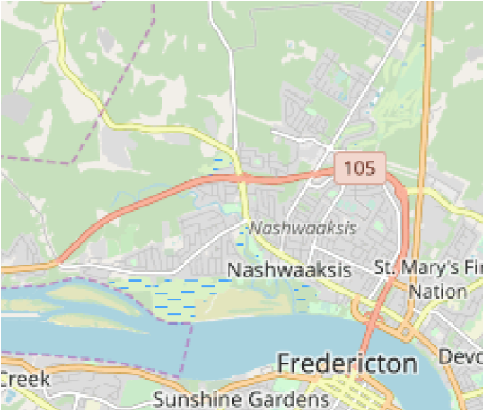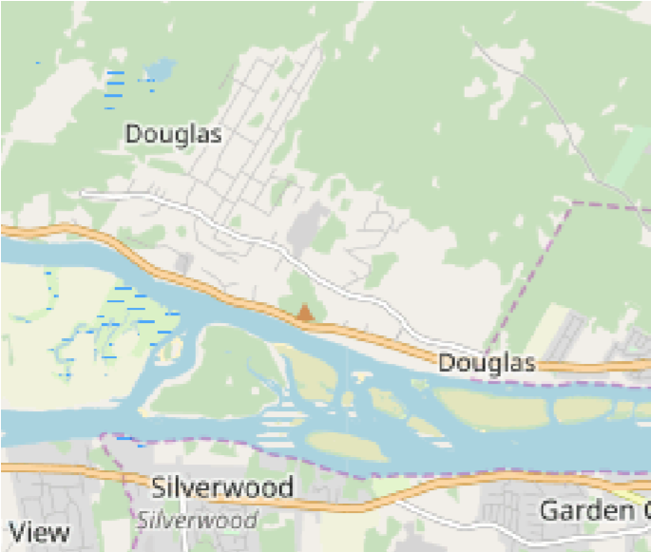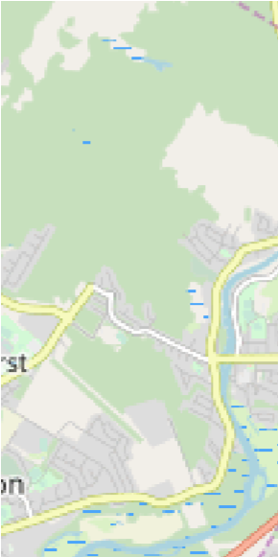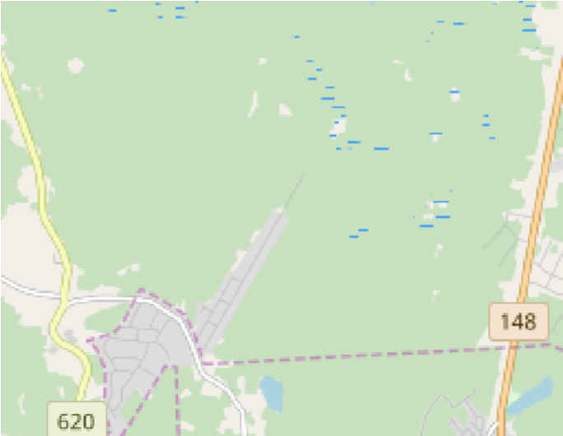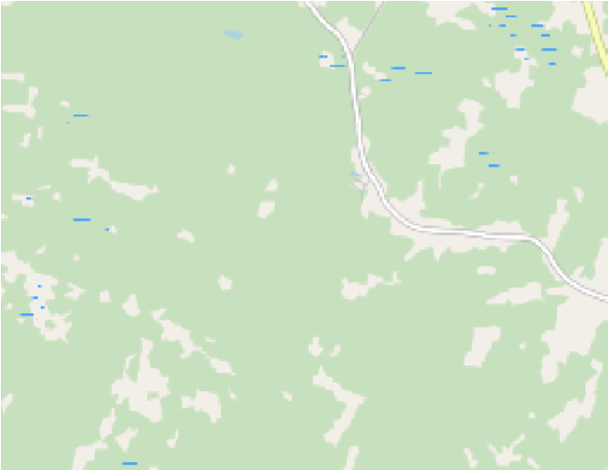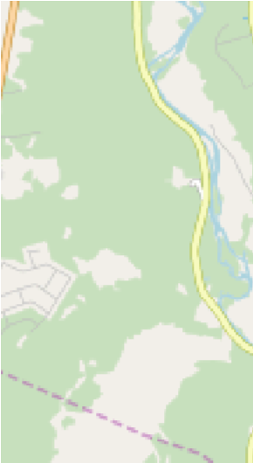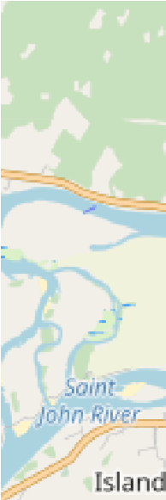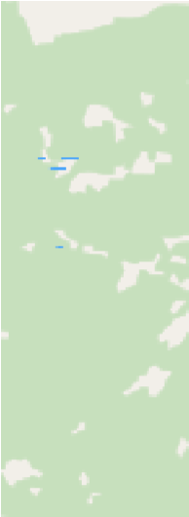

+

~~−~~

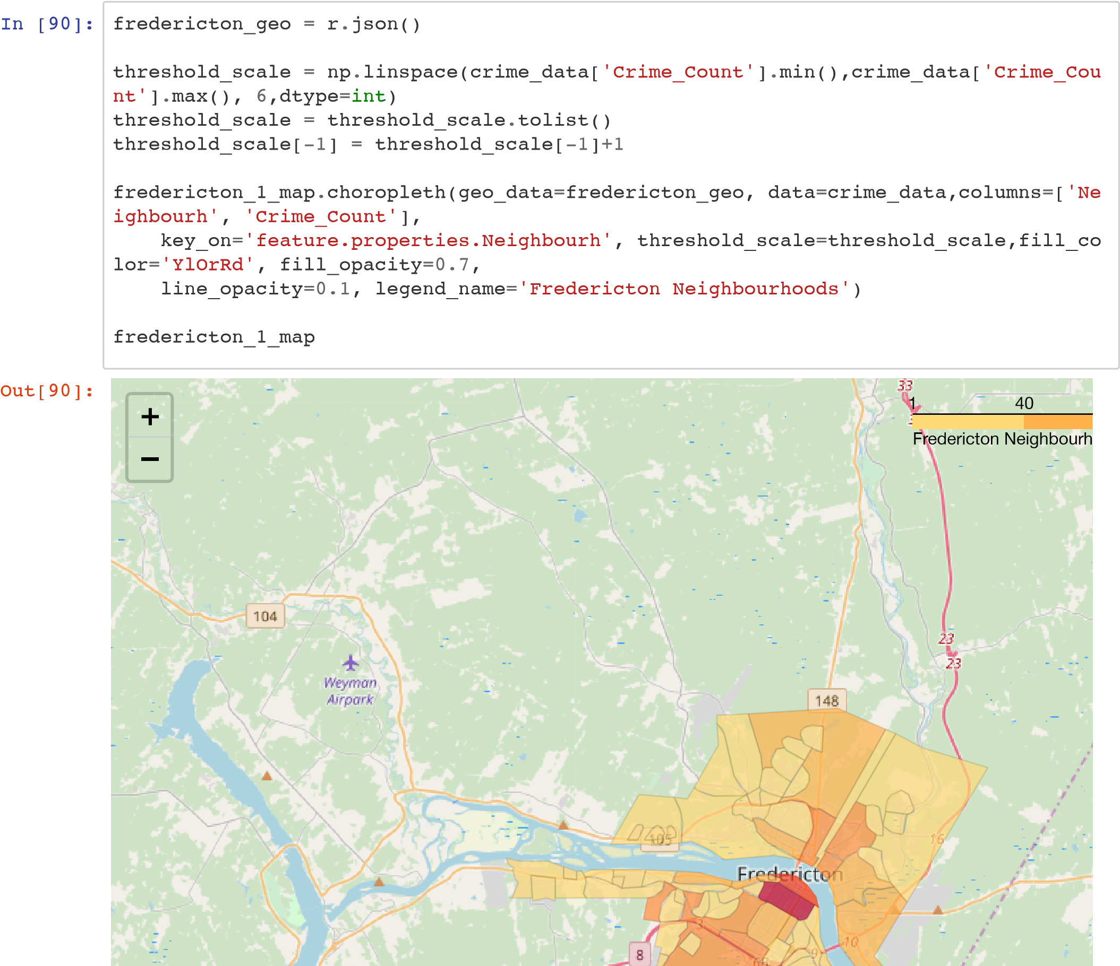

# Examine Crime Types

In [131]:

crimetype_data

=

crime_df

.

groupby

([

'Crime_Type'

])

.

size

()

.

to_frame

(

name

=

'Count'

)

.

res

et_index

()

crimetype_data

Out[131]:

**Crime_Type Count**

1. 4
2. ARSON 5
3. ARSON BY NEG 1
4. ARSON-DAM.PROP. 4
5. B&E NON-RESIDNCE 51
6. B&E OTHER 58
7. B&E RESIDENCE 151
8. B&E STEAL FIREAR 3 **8** MISCHIEF OBS USE 1
9. MISCHIEF TO PROP 246
10. MISCHIEF-DATA 2
11. MOTOR VEH THEFT 40
12. THEFT BIKE<$5000 63
13. THEFT FROM MV < $5000 356
14. THEFT FROM MV > $5000 5
15. THEFT OTH <$5000 458
16. THEFT OTH >$5000 9 **17** THEFT OVER $5000 1

**18** THEFT,BIKE>$5000 2

In [154]:

crimetype_data

.

describe

()

Out[154]:

**C**

**o**

**u**

**n**

**t**

**c**

**o**

**u**

**n**

**t**

1

9

.

0

0

0

0

0

0

**mean** 76.842105 **std** 133.196706

**min** 1.000000 **25%** 2.500000 **50%** 5.000000 **75%** 60.500000 **max** 458.000000

In [140]: crimepivot = crime_df.pivot_table(index='Neighbourhood', columns='Crime_Type', aggf unc=pd.Series.count, fill_value=0) crimepivot

Out[140]:

**City**

**ARSON B&E**

**Crime_Type ARSON BY ARSON B&E NON B&E B&E STEAL MISCHIEF MISCHIE**

**NEG DAM.PROP. RESIDNCE OTHER RESIDENCE FIREAR OBS USE TO PRO**

**Neighbourhood**

**Barkers Point** 0 0 0 0 2 7 7 1 0

**Brookside** 0 0 0 0 2 0 0 0 0

**Brookside** 0 0 0 0 1 1 0 0 0

**Estates**

**Brookside Mini** 0 0 0 0 0 0 0 1 0

**Home Park**

**College Hill** 0 2 0 0 0 2 13 0 0

**Colonial** 0 0 0 0 0 0 3 0 0 **heights**

**Cotton Mill** 0 0 0 0 0 0 0 0 0 **Creek**

**Diamond** 0 0 0 0 0 0 0 0 0

**Street**

**Doak Road** 0 0 0 0 0 0 0 0 0

**Douglas** 0 0 0 0 0 0 0 0 0

**Downtown** 0 1 0 1 7 0 3 0 0

**Dun's Crossing** 0 0 0 0 0 0 1 0 0

**Forest Hill** 0 0 0 0 1 0 0 0 0

**Fredericton** 1 0 0 0 6 1 1 0 0

**South**

**Fulton Heights** 0 0 0 0 1 0 6 0 0

**Garden Creek** 0 0 0 0 2 1 1 0 0

**Garden Place** 0 0 0 0 0 0 0 0 0

**Gilridge** 0 0 0 0 0 0 0 0 0

**Estates**

**Golf Club** 0 0 0 0 0 0 1 0 0

**Grasse Circle** 1 0 0 0 0 0 0 0 0

**Greenwood** 0 0 0 0 0 1 0 0 0

**Minihome Park**

**Hanwell North** 0 0 0 0 0 1 2 0 0

**Heron Springs** 0 0 0 0 0 0 1 0 0

**Highpoint** 0 0 0 0 0 0 0 0 0 **Ridge**

**Kelly's Court** 0 0 0 0 0 0 0 0 0

**Minihome Park**

**Knob Hill** 0 0 0 0 0 0 1 0 0

**Knowledge** 1 0 0 0 0 0 0 0 0

**Park**

**Lian / Valcore** 0 0 0 0 0 0 0 0 0

**Lincoln** 0 0 0 0 2 2 2 0 0

**City**

**ARSON B&E**

**Crime_Type ARSON BY ARSON B&E NON B&E B&E STEAL MISCHIEF MISCHIE**

**NEG DAM.PROP. RESIDNCE OTHER RESIDENCE FIREAR OBS USE TO PRO**

**Neighbourhood**

**Lincoln** 0 0 0 0 0 1 1 0 0

**Heights**

**Main Street** 0 0 0 1 2 4 8 0 1

**Marysville** 0 1 0 0 1 2 5 0 0

**McKnight** 0 0 0 0 0 0 0 0 0

**McLeod Hill** 0 0 0 0 0 0 0 0 0

**Monteith /** 0 0 0 0 2 2 4 0 0 **Talisman**

**Montogomery /** 0 0 0 0 0 0 0 0 0

**Prospect East**

**Nashwaaksis** 0 0 0 1 2 0 3 0 0

**Nethervue** 0 0 0 0 0 0 0 0 0

**Minihome Park**

**North Devon** 0 0 0 0 5 4 11 0 0

**Northbrook** 0 0 0 0 0 0 2 0 0

**Heights**

**Plat** 0 0 0 0 4 10 18 0 0

**Poet's Hill** 0 0 0 0 0 0 1 0 0

**Prospect** 0 0 0 0 1 0 2 0 0

**Rail Side** 0 0 0 0 0 0 0 0 0

**Regiment** 0 0 0 0 0 0 0 0 0

**Creek**

**Royal Road** 0 0 0 0 3 2 2 0 0

**Saint Mary's** 0 0 0 0 0 0 1 0 0

**First Nation**

**Saint Thomas** 0 0 0 0 0 0 0 0 0

**University**

**Sandyville** 0 0 0 0 0 2 2 0 0

**Serenity Lane** 0 0 0 0 1 1 0 0 0

**Shadowood** 0 0 0 0 0 0 0 0 0

**Estates**

**Silverwood** 0 0 0 0 0 0 3 0 0

**Skyline Acrea** 0 1 0 0 1 1 2 0 0

**South Devon** 0 0 1 0 0 6 16 0 0

**Southwood** 0 0 0 0 0 0 2 0 0

**Park**

**Springhill** 0 0 0 0 0 0 1 0 0

**Sunshine** 0 0 0 0 0 1 0 0 0

**Gardens**

**The Hill** 0 0 0 0 2 1 12 1 0

**City**

**ARSON B&E**

**Crime_Type ARSON BY ARSON B&E NON B&E B&E STEAL MISCHIEF MISCHIE**

**NEG DAM.PROP. RESIDNCE OTHER RESIDENCE FIREAR OBS USE TO PRO**

**Neighbourhood**

**The Hugh John**

**Flemming** 0 0 0 0 1 2 0 0 0

**Forestry**

**Center**

**University Of**

**New** 0 0 0 0 0 0 1 0 0

**Brunswick**

**Waterloo Row** 0 0 0 0 0 1 2 0 0

**Wesbett / Case** 1 0 0 0 0 0 0 0 0

**West Hills** 0 0 0 0 0 1 1 0 0

**Williams /** 0 0 0 0 0 1 2 0 0

**Hawkins Area**

**Woodstock** 0 0 0 0 2 0 5 0 0

**Road**

**Youngs** 0 0 0 1 0 0 2 0 0

**Crossing**

In [92]:

crimetype_data

.

plot

(

x

=

'Crime_Type'

,

y

=

'Count'

,

kind

=

'barh'

)



In [ ]:

Out[92]:

<

matplotlib.axes._subplots.AxesSubplot at

0x11682a860>

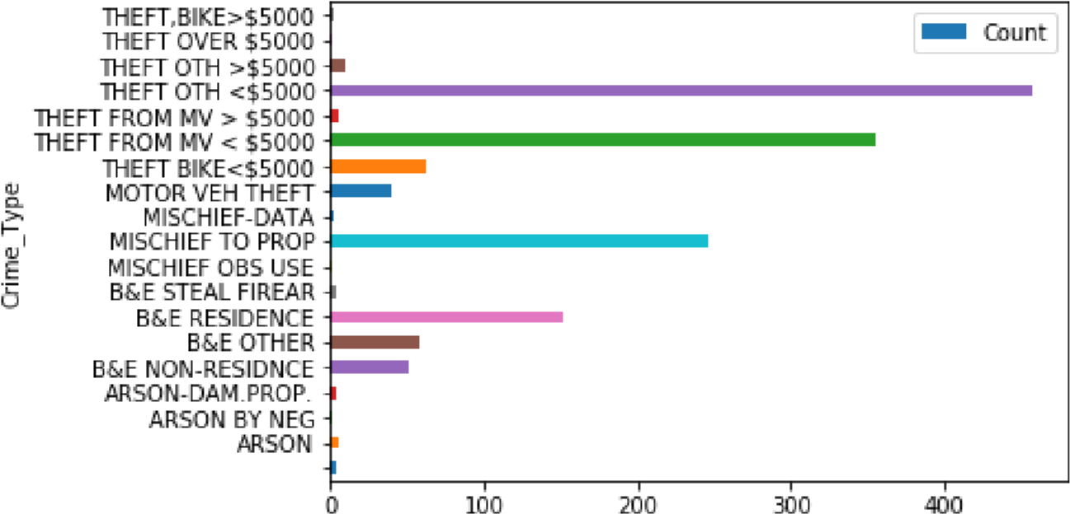

# Let's examine theft from vehicles

In [93]: mvcrime_df = crime_df.loc[crime_df['Crime_Type'] == 'THEFT FROM MV < $5000'] mvcrime_df

Out[93]:

**Neighbourhood Crime_Code Crime_Type Ward City FID**

**18** Fredericton South 2142 THEFT FROM MV < $5000 7 Fredericton 19 **19** Fredericton South 2142 THEFT FROM MV < $5000 7 Fredericton 20 **20** Fredericton South 2142 THEFT FROM MV < $5000 7 Fredericton 21

**21** Fredericton South 2142 THEFT FROM MV < $5000 12 Fredericton 22 **22** Fredericton South 2142 THEFT FROM MV < $5000 12 Fredericton 23

**23** Fredericton South 2142 THEFT FROM MV < $5000 7 Fredericton 24 **24** Fredericton South 2142 THEFT FROM MV < $5000 7 Fredericton 25 **25** Fredericton South 2142 THEFT FROM MV < $5000 7 Fredericton 26

**26** Fredericton South 2142 THEFT FROM MV < $5000 11 Fredericton 27 **27** Fredericton South 2142 THEFT FROM MV < $5000 11 Fredericton 28 **28** Fredericton South 2142 THEFT FROM MV < $5000 12 Fredericton 29 **29** Fredericton South 2142 THEFT FROM MV < $5000 12 Fredericton 30

**30** Fredericton South 2142 THEFT FROM MV < $5000 7 Fredericton 31

**51** Barkers Point 2142 THEFT FROM MV < $5000 6 Fredericton 52 **52** Barkers Point 2142 THEFT FROM MV < $5000 6 Fredericton 53 **53** Barkers Point 2142 THEFT FROM MV < $5000 6 Fredericton 54 **54** Barkers Point 2142 THEFT FROM MV < $5000 6 Fredericton 55 **55** Barkers Point 2142 THEFT FROM MV < $5000 6 Fredericton 56 **56** Barkers Point 2142 THEFT FROM MV < $5000 6 Fredericton 57 **57** Barkers Point 2142 THEFT FROM MV < $5000 6 Fredericton 58 **58** Barkers Point 2142 THEFT FROM MV < $5000 6 Fredericton 59

**100** Sandyville 2142 THEFT FROM MV < $5000 5 Fredericton 101

**107** South Devon 2142 THEFT FROM MV < $5000 4 Fredericton 108 **108** South Devon 2142 THEFT FROM MV < $5000 4 Fredericton 109 **109** South Devon 2142 THEFT FROM MV < $5000 4 Fredericton 110 **110** South Devon 2142 THEFT FROM MV < $5000 4 Fredericton 111 **111** South Devon 2142 THEFT FROM MV < $5000 4 Fredericton 112 **112** South Devon 2142 THEFT FROM MV < $5000 4 Fredericton 113 **113** South Devon 2142 THEFT FROM MV < $5000 4 Fredericton 114 **114** South Devon 2142 THEFT FROM MV < $5000 4 Fredericton 115 **115** South Devon 2142 THEFT FROM MV < $5000 4 Fredericton 116 **116** South Devon 2142 THEFT FROM MV < $5000 4 Fredericton 117 **117** South Devon 2142 THEFT FROM MV < $5000 4 Fredericton 118 **118** South Devon 2142 THEFT FROM MV < $5000 4 Fredericton 119 **119** South Devon 2142 THEFT FROM MV < $5000 4 Fredericton 120 **120** South Devon 2142 THEFT FROM MV < $5000 4 Fredericton 121 **121** South Devon 2142 THEFT FROM MV < $5000 4 Fredericton 122 **122** South Devon 2142 THEFT FROM MV < $5000 4 Fredericton 123 **123** South Devon 2142 THEFT FROM MV < $5000 4 Fredericton 124

**Neighbourhood Crime_Code Crime_Type Ward City FID**

|  |  |  |  |  |  |  |
| --- | --- | --- | --- | --- | --- | --- |
| **124** | South Devon | 2142 | THEFT FROM MV < $5000 | 4 | Fredericton | 125 |
| **125** | South Devon | 2142 | THEFT FROM MV < $5000 | 4 | Fredericton | 126 |
| **126** | South Devon | 2142 | THEFT FROM MV < $5000 | 4 | Fredericton | 127 |
| **127** | South Devon | 2142 | THEFT FROM MV < $5000 | 4 | Fredericton | 128 |
| **128** | South Devon | 2142 | THEFT FROM MV < $5000 | 4 | Fredericton | 129 |
| **151** | Sandyville | 2142 | THEFT FROM MV < $5000 | 5 | Fredericton | 152 |
| **156** | Knob Hill | 2142 | THEFT FROM MV < $5000 | 5 | Fredericton | 157 |
| **165** | Youngs Crossing | 2142 | THEFT FROM MV < $5000 | 4 | Fredericton | 166 |
| **166** | Youngs Crossing | 2142 | THEFT FROM MV < $5000 | 4 | Fredericton | 167 |
| **167** | Youngs Crossing | 2142 | THEFT FROM MV < $5000 | 4 | Fredericton | 168 |
| **168** | Youngs Crossing | 2142 | THEFT FROM MV < $5000 | 4 | Fredericton | 169 |
| **169** | Youngs Crossing | 2142 | THEFT FROM MV < $5000 | 4 | Fredericton | 170 |
| **170** | Youngs Crossing | 2142 | THEFT FROM MV < $5000 | 4 | Fredericton | 171 |
| **201** | Marysville | 2142 | THEFT FROM MV < $5000 | 5 | Fredericton | 202 |
| **252** | Marysville | 2142 | THEFT FROM MV < $5000 | 5 | Fredericton | 253 |
| **278** | Douglas | 2142 | THEFT FROM MV < $5000 | 1 | Fredericton | 279 |
| **280** | McLeod Hill | 2142 | THEFT FROM MV < $5000 | 2 | Fredericton | 281 |
| **281** | McLeod Hill | 2142 | THEFT FROM MV < $5000 | 2 | Fredericton | 282 |
| **301** | Marysville | 2142 | THEFT FROM MV < $5000 | 0 | Fredericton | 302 |
| **302** | Marysville | 2142 | THEFT FROM MV < $5000 | 5 | Fredericton | 303 |
| **303** | Marysville | 2142 | THEFT FROM MV < $5000 | 5 | Fredericton | 304 |
| **304** | Marysville | 2142 | THEFT FROM MV < $5000 | 5 | Fredericton | 305 |
| **305** | Marysville | 2142 | THEFT FROM MV < $5000 | 5 | Fredericton | 306 |
| **306** | Marysville | 2142 | THEFT FROM MV < $5000 | 5 | Fredericton | 307 |
| **307** | Marysville | 2142 | THEFT FROM MV < $5000 | 5 | Fredericton | 308 |
| **308** | Marysville | 2142 | THEFT FROM MV < $5000 | 5 | Fredericton | 309 |
| **330** | Saint Mary's First Nation | 2142 | THEFT FROM MV < $5000 | 3 | Fredericton | 331 |
| **349** | Sandyville | 2142 | THEFT FROM MV < $5000 | 5 | Fredericton | 350 |
| **354** | Nashwaaksis | 2142 | THEFT FROM MV < $5000 | 1 | Fredericton | 355 |
| **355** | Nashwaaksis | 2142 | THEFT FROM MV < $5000 | 1 | Fredericton | 356 |
| **356** | Nashwaaksis | 2142 | THEFT FROM MV < $5000 | 1 | Fredericton | 357 |
| **357** | Nashwaaksis | 2142 | THEFT FROM MV < $5000 | 1 | Fredericton | 358 |
| **358** | Nashwaaksis | 2142 | THEFT FROM MV < $5000 | 1 | Fredericton | 359 |
| **359** | Nashwaaksis | 2142 | THEFT FROM MV < $5000 | 1 | Fredericton | 360 |
| **360** | Nashwaaksis | 2142 | THEFT FROM MV $5000 | 1 | Fredericton | 361 |
| **361** | Nashwaaksis | 2142 | THEFT FROM MV $5000 | 1 | Fredericton | 362 |
| **362** | Nashwaaksis | 2142 | THEFT FROM MV $5000 | 1 | Fredericton | 363 |
| **377** | Northbrook Heights | 2142 | THEFT FROM MV $5000 | 2 | Fredericton | 378 |
| **378** | Northbrook Heights |  |  |  |  | 379 |

**Neighbourhood Crime_Code Crime_Type Ward City FID**

**379** Northbrook Heights 2142 THEFT FROM MV < $5000 1 Fredericton 380 **380** Northbrook Heights 2142 THEFT FROM MV < $5000 2 Fredericton 381 **381** Northbrook Heights 2142 THEFT FROM MV < $5000 2 Fredericton 382

**388** Heron Springs 2142 THEFT FROM MV < $5000 2 Fredericton 389 **389** Heron Springs 2142 THEFT FROM MV < $5000 2 Fredericton 390

**400** Downtown 2142 THEFT FROM MV < $5000 10 Fredericton 401 **401** Downtown 2142 THEFT FROM MV < $5000 11 Fredericton 402 **402** Downtown 2142 THEFT FROM MV < $5000 11 Fredericton 403 **403** Downtown 2142 THEFT FROM MV < $5000 10 Fredericton 404 **404** Downtown 2142 THEFT FROM MV < $5000 10 Fredericton 405 **405** Downtown 2142 THEFT FROM MV < $5000 10 Fredericton 406 **408** Downtown 2142 THEFT FROM MV < $5000 10 Fredericton 409 **410** Downtown 2142 THEFT FROM MV < $5000 10 Fredericton 411 **411** Downtown 2142 THEFT FROM MV < $5000 10 Fredericton 412 **412** Downtown 2142 THEFT FROM MV < $5000 10 Fredericton 413 **413** Downtown 2142 THEFT FROM MV < $5000 10 Fredericton 414 **414** Downtown 2142 THEFT FROM MV < $5000 10 Fredericton 415 **415** Downtown 2142 THEFT FROM MV < $5000 10 Fredericton 416 **416** Downtown 2142 THEFT FROM MV < $5000 10 Fredericton 417 **417** Downtown 2142 THEFT FROM MV < $5000 10 Fredericton 418 **418** Downtown 2142 THEFT FROM MV < $5000 10 Fredericton 419 **419** Downtown 2142 THEFT FROM MV < $5000 10 Fredericton 420 **420** Downtown 2142 THEFT FROM MV < $5000 10 Fredericton 421 **421** Downtown 2142 THEFT FROM MV < $5000 10 Fredericton 422 **422** Downtown 2142 THEFT FROM MV < $5000 10 Fredericton 423 **506** Downtown 2142 THEFT FROM MV < $5000 10 Fredericton 507

**520** Fulton Heights 2142 THEFT FROM MV < $5000 3 Fredericton 521 **521** Fulton Heights 2142 THEFT FROM MV < $5000 3 Fredericton 522 **522** Fulton Heights 2142 THEFT FROM MV < $5000 3 Fredericton 523 **523** Fulton Heights 2142 THEFT FROM MV < $5000 3 Fredericton 524 **524** Fulton Heights 2142 THEFT FROM MV < $5000 2 Fredericton 525 **525** Fulton Heights 2142 THEFT FROM MV < $5000 3 Fredericton 526 **526** Fulton Heights 2142 THEFT FROM MV < $5000 3 Fredericton 527 **527** Fulton Heights 2142 THEFT FROM MV < $5000 3 Fredericton 528

**528** Fulton Heights 3 529 **529** Fulton Heights 2 530 **530** Fulton Heights 3 531

**531** Fulton Heights 3 532

**56** Main Street 57 **Neighbourhood Crime_Code Crime_Type Ward City FID**

**570** Main Street 2142 THEFT FROM MV < $5000 3 Fredericton 571 **571** Main Street 2142 THEFT FROM MV < $5000 2 Fredericton 572 **572** Main Street 2142 THEFT FROM MV < $5000 2 Fredericton 573 **573** Main Street 2142 THEFT FROM MV < $5000 3 Fredericton 574 **574** Main Street 2142 THEFT FROM MV < $5000 2 Fredericton 575 **575** Main Street 2142 THEFT FROM MV < $5000 2 Fredericton 576 **576** Main Street 2142 THEFT FROM MV < $5000 2 Fredericton 577 **577** Main Street 2142 THEFT FROM MV < $5000 2 Fredericton 578 **578** Main Street 2142 THEFT FROM MV < $5000 2 Fredericton 579

**604** Golf Club 2142 THEFT FROM MV < $5000 12 Fredericton 605

**614** Gilridge Estates 2142 THEFT FROM MV < $5000 1 Fredericton 615

**622** Nethervue Minihome Park 2142 THEFT FROM MV < $5000 12 Fredericton 623

**625** Monteith / Talisman 2142 THEFT FROM MV < $5000 12 Fredericton 626 **626** Monteith / Talisman 2142 THEFT FROM MV < $5000 12 Fredericton 627

**631** Garden Creek 2142 THEFT FROM MV < $5000 12 Fredericton 632

**640** Highpoint Ridge 2142 THEFT FROM MV < $5000 12 Fredericton 641 **641** Highpoint Ridge 2142 THEFT FROM MV < $5000 12 Fredericton 642 **642** Highpoint Ridge 2142 THEFT FROM MV < $5000 12 Fredericton 643 **643** Highpoint Ridge 2142 THEFT FROM MV < $5000 12 Fredericton 644

**650** Golf Club 2142 THEFT FROM MV < $5000 12 Fredericton 651 **651** Golf Club 2142 THEFT FROM MV < $5000 12 Fredericton 652 **653** Golf Club 2142 THEFT FROM MV < $5000 12 Fredericton 654 **752** Golf Club 2142 THEFT FROM MV < $5000 12 Fredericton 753

**764** Woodstock Road 2142 THEFT FROM MV < $5000 12 Fredericton 765 **765** Woodstock Road 2142 THEFT FROM MV < $5000 12 Fredericton 766 **766** Woodstock Road 2142 THEFT FROM MV < $5000 12 Fredericton 767 **767** Woodstock Road 2142 THEFT FROM MV < $5000 12 Fredericton 768 **768** Woodstock Road 2142 THEFT FROM MV < $5000 12 Fredericton 769 **769** Woodstock Road 2142 THEFT FROM MV < $5000 12 Fredericton 770 **770** Woodstock Road 2142 THEFT FROM MV < $5000 12 Fredericton 771 **771** Woodstock Road 2142 THEFT FROM MV < $5000 12 Fredericton 772 **772** Woodstock Road 2142 THEFT FROM MV < $5000 12 Fredericton 773 **773** Woodstock Road 2142 THEFT FROM MV < $5000 12 Fredericton 774 **774** Woodstock Road 2142 THEFT FROM MV < $5000 12 Fredericton 775

1. Woodstock Road 12 776
2. Woodstock Road 0 777
3. Woodstock Road 12 778
4. Woodstock Road 12 779

**77** Woodstock Road 1 78

**Neighbourhood Crime_Code Crime_Type Ward City FID**

**780** Woodstock Road 2142 THEFT FROM MV < $5000 12 Fredericton 781 **781** Woodstock Road 2142 THEFT FROM MV < $5000 12 Fredericton 782

**787** Sunshine Gardens 2142 THEFT FROM MV < $5000 10 Fredericton 788 **788** Sunshine Gardens 2142 THEFT FROM MV < $5000 10 Fredericton 789 **789** Sunshine Gardens 2142 THEFT FROM MV < $5000 10 Fredericton 790 **790** Sunshine Gardens 2142 THEFT FROM MV < $5000 10 Fredericton 791 **791** Sunshine Gardens 2142 THEFT FROM MV < $5000 10 Fredericton 792 **792** Sunshine Gardens 2142 THEFT FROM MV < $5000 10 Fredericton 793 **793** Sunshine Gardens 2142 THEFT FROM MV < $5000 10 Fredericton 794

1. Plat 2142 THEFT FROM MV < $5000 0 Fredericton 810
2. Plat 2142 THEFT FROM MV < $5000 11 Fredericton 811 **811** Plat 2142 THEFT FROM MV < $5000 11 Fredericton 812 **812** Plat 2142 THEFT FROM MV < $5000 10 Fredericton 813 **813** Plat 2142 THEFT FROM MV < $5000 11 Fredericton 814 **814** Plat 2142 THEFT FROM MV < $5000 10 Fredericton 815 **815** Plat 2142 THEFT FROM MV < $5000 10 Fredericton 816 **816** Plat 2142 THEFT FROM MV < $5000 10 Fredericton 817 **817** Plat 2142 THEFT FROM MV < $5000 10 Fredericton 818 **818** Plat 2142 THEFT FROM MV < $5000 10 Fredericton 819 **819** Plat 2142 THEFT FROM MV < $5000 11 Fredericton 820 **820** Plat 2142 THEFT FROM MV < $5000 10 Fredericton 821 **821** Plat 2142 THEFT FROM MV < $5000 10 Fredericton 822 **822** Plat 2142 THEFT FROM MV < $5000 10 Fredericton 823 **823** Plat 2142 THEFT FROM MV < $5000 10 Fredericton 824 **824** Plat 2142 THEFT FROM MV < $5000 10 Fredericton 825
3. Plat 2142 THEFT FROM MV < $5000 0 Fredericton 826
4. Plat 2142 THEFT FROM MV < $5000 11 Fredericton 827 **827** Plat 2142 THEFT FROM MV < $5000 10 Fredericton 828 **828** Plat 2142 THEFT FROM MV < $5000 10 Fredericton 829 **829** Plat 2142 THEFT FROM MV < $5000 10 Fredericton 830 **830** Plat 2142 THEFT FROM MV < $5000 11 Fredericton 831 **831** Plat 2142 THEFT FROM MV < $5000 11 Fredericton 832 **832** Plat 2142 THEFT FROM MV < $5000 10 Fredericton 833 **833** Plat 2142 THEFT FROM MV < $5000 11 Fredericton 834

**835** Plat 10 836 **836** Plat 11 837 **837** Plat 10 838

**838** Plat 10 839

**8** Plat 11 84 **Neighbourhood Crime_Code Crime_Type Ward City FID**

**840** Plat 2142 THEFT FROM MV < $5000 10 Fredericton 841 **841** Plat 2142 THEFT FROM MV < $5000 10 Fredericton 842 **842** Plat 2142 THEFT FROM MV < $5000 10 Fredericton 843 **843** Plat 2142 THEFT FROM MV < $5000 10 Fredericton 844 **844** Plat 2142 THEFT FROM MV < $5000 10 Fredericton 845 **845** Plat 2142 THEFT FROM MV < $5000 11 Fredericton 846 **846** Plat 2142 THEFT FROM MV < $5000 10 Fredericton 847 **847** Plat 2142 THEFT FROM MV < $5000 10 Fredericton 848 **848** Plat 2142 THEFT FROM MV < $5000 11 Fredericton 849 **849** Plat 2142 THEFT FROM MV < $5000 10 Fredericton 850

**855** Southwood Park 2142 THEFT FROM MV < $5000 7 Fredericton 856 **856** Southwood Park 2142 THEFT FROM MV < $5000 7 Fredericton 857 **857** Southwood Park 2142 THEFT FROM MV < $5000 7 Fredericton 858

**865** Lincoln Heights 2142 THEFT FROM MV < $5000 7 Fredericton 866 **866** Lincoln Heights 2142 THEFT FROM MV < $5000 7 Fredericton 867 **867** Lincoln Heights 2142 THEFT FROM MV < $5000 7 Fredericton 868 **868** Lincoln Heights 2142 THEFT FROM MV < $5000 7 Fredericton 869 **869** Lincoln Heights 2142 THEFT FROM MV < $5000 7 Fredericton 870 **871** Lincoln Heights 2142 THEFT FROM MV < $5000 7 Fredericton 872 **875** Lincoln Heights 2142 THEFT FROM MV < $5000 7 Fredericton 876

1. Skyline Acrea 2142 THEFT FROM MV < $5000 8 Fredericton 881
2. Lincoln Heights 2142 THEFT FROM MV < $5000 7 Fredericton 882
3. Skyline Acrea 2142 THEFT FROM MV < $5000 8 Fredericton 887
4. Lincoln Heights 2142 THEFT FROM MV < $5000 7 Fredericton 888
5. Skyline Acrea 2142 THEFT FROM MV < $5000 8 Fredericton 893
6. Lincoln Heights 2142 THEFT FROM MV < $5000 7 Fredericton 894

**898** Skyline Acrea 2142 THEFT FROM MV < $5000 8 Fredericton 899 **899** Skyline Acrea 2142 THEFT FROM MV < $5000 8 Fredericton 900 **900** Skyline Acrea 2142 THEFT FROM MV < $5000 8 Fredericton 901 **901** Skyline Acrea 2142 THEFT FROM MV < $5000 8 Fredericton 902 **902** Skyline Acrea 2142 THEFT FROM MV < $5000 8 Fredericton 903 **903** Skyline Acrea 2142 THEFT FROM MV < $5000 8 Fredericton 904 **904** Skyline Acrea 2142 THEFT FROM MV < $5000 8 Fredericton 905 **905** Skyline Acrea 2142 THEFT FROM MV < $5000 8 Fredericton 906

**906** Skyline Acrea 8 907 **907** Skyline Acrea 8 908

**913** Poet's Hill 8 914 **914** Poet's Hill 8 915

1. Dun's Crossing 8 923 **Neighbourhood Crime_Code Crime_Type Ward City FID**
2. Dun's Crossing 2142 THEFT FROM MV < $5000 8 Fredericton 924 **924** Dun's Crossing 2142 THEFT FROM MV < $5000 8 Fredericton 925 **925** Dun's Crossing 2142 THEFT FROM MV < $5000 8 Fredericton 926 **926** Dun's Crossing 2142 THEFT FROM MV < $5000 8 Fredericton 927 **927** Dun's Crossing 2142 THEFT FROM MV < $5000 8 Fredericton 928 **928** Dun's Crossing 2142 THEFT FROM MV < $5000 8 Fredericton 929 **929** Dun's Crossing 2142 THEFT FROM MV < $5000 8 Fredericton 930 **930** Dun's Crossing 2142 THEFT FROM MV < $5000 8 Fredericton 931 **938** Southwood Park 2142 THEFT FROM MV < $5000 7 Fredericton 939 **939** Southwood Park 2142 THEFT FROM MV < $5000 7 Fredericton 940 **940** Southwood Park 2142 THEFT FROM MV < $5000 7 Fredericton 941 **941** Southwood Park 2142 THEFT FROM MV < $5000 7 Fredericton 942

**946** The Hill 2142 THEFT FROM MV < $5000 9 Fredericton 947 **947** The Hill 2142 THEFT FROM MV < $5000 9 Fredericton 948 **948** The Hill 2142 THEFT FROM MV < $5000 9 Fredericton 949

**949** The Hill 2142 THEFT FROM MV < $5000 10 Fredericton 950 **950** The Hill 2142 THEFT FROM MV < $5000 10 Fredericton 951 **951** The Hill 2142 THEFT FROM MV < $5000 11 Fredericton 952

**952** The Hill 2142 THEFT FROM MV < $5000 9 Fredericton 953

**954** The Hill 2142 THEFT FROM MV < $5000 10 Fredericton 955 **955** The Hill 2142 THEFT FROM MV < $5000 10 Fredericton 956

**956** The Hill 2142 THEFT FROM MV < $5000 9 Fredericton 957 **957** The Hill 2142 THEFT FROM MV < $5000 9 Fredericton 958

**969** Forest Hill 2142 THEFT FROM MV < $5000 8 Fredericton 970 **970** Forest Hill 2142 THEFT FROM MV < $5000 8 Fredericton 971 **971** Forest Hill 2142 THEFT FROM MV < $5000 8 Fredericton 972 **972** Forest Hill 2142 THEFT FROM MV < $5000 8 Fredericton 973 **973** Forest Hill 2142 THEFT FROM MV < $5000 8 Fredericton 974 **974** Forest Hill 2142 THEFT FROM MV < $5000 8 Fredericton 975 **975** Forest Hill 2142 THEFT FROM MV < $5000 8 Fredericton 976 **976** Forest Hill 2142 THEFT FROM MV < $5000 8 Fredericton 977

**989** Lincoln Heights 2142 THEFT FROM MV < $5000 7 Fredericton 990

**996** Diamond Street 2142 THEFT FROM MV < $5000 1 Fredericton 997

1. College Hill 2142 THEFT FROM MV < $5000 11 Fredericton 1028
2. College Hill 11 1029 **1029** College Hill 11 1030 **1030** College Hill 11 1031 **1031** College Hill 11 1032

**10 2** College Hill 11 1033

**Neighbourhood Crime_Code Crime_Type Ward City FID**

**1033** College Hill 2142 THEFT FROM MV < $5000 11 Fredericton 1034 **1034** College Hill 2142 THEFT FROM MV < $5000 11 Fredericton 1035 **1035** College Hill 2142 THEFT FROM MV < $5000 11 Fredericton 1036 **1036** College Hill 2142 THEFT FROM MV < $5000 11 Fredericton 1037

**1060** Brookside Estates 2142 THEFT FROM MV < $5000 2 Fredericton 1061 **1061** Brookside Estates 2142 THEFT FROM MV < $5000 2 Fredericton 1062 **1062** Brookside Estates 2142 THEFT FROM MV < $5000 2 Fredericton 1063

**1116** Lincoln 2142 THEFT FROM MV < $5000 7 Fredericton 1117

**1124** Colonial heights 2142 THEFT FROM MV < $5000 12 Fredericton 1125 **1125** Colonial heights 2142 THEFT FROM MV < $5000 12 Fredericton 1126 **1126** Colonial heights 2142 THEFT FROM MV < $5000 12 Fredericton 1127 **1127** Colonial heights 2142 THEFT FROM MV < $5000 12 Fredericton 1128 **1128** Colonial heights 2142 THEFT FROM MV < $5000 11 Fredericton 1129 **1129** Colonial heights 2142 THEFT FROM MV < $5000 11 Fredericton 1130

**1131** Garden Place 2142 THEFT FROM MV < $5000 12 Fredericton 1132 **1132** Garden Place 2142 THEFT FROM MV < $5000 12 Fredericton 1133 **1133** Garden Place 2142 THEFT FROM MV < $5000 12 Fredericton 1134 **1144** Waterloo Row 2142 THEFT FROM MV < $5000 11 Fredericton 1145 **1145** Waterloo Row 2142 THEFT FROM MV < $5000 11 Fredericton 1146 **1146** Waterloo Row 2142 THEFT FROM MV < $5000 11 Fredericton 1147

**1151** University Of New Brunswick 2142 THEFT FROM MV < $5000 11 Fredericton 1152 **1152** University Of New Brunswick 2142 THEFT FROM MV < $5000 11 Fredericton 1153 **1153** University Of New Brunswick 2142 THEFT FROM MV < $5000 11 Fredericton 1154 **1154** University Of New Brunswick 2142 THEFT FROM MV < $5000 11 Fredericton 1155

**1163** Saint Thomas University 2142 THEFT FROM MV < $5000 11 Fredericton 1164

**1173** Williams / Hawkins Area 2142 THEFT FROM MV < $5000 2 Fredericton 1174 **1174** Williams / Hawkins Area 2142 THEFT FROM MV < $5000 2 Fredericton 1175 **1175** Williams / Hawkins Area 2142 THEFT FROM MV < $5000 2 Fredericton 1176 **1176** Williams / Hawkins Area 2142 THEFT FROM MV < $5000 2 Fredericton 1177 **1177** Williams / Hawkins Area 2142 THEFT FROM MV < $5000 2 Fredericton 1178 **1178** Williams / Hawkins Area 2142 THEFT FROM MV < $5000 2 Fredericton 1179

**1181** McKnight 2142 THEFT FROM MV < $5000 2 Fredricton 1182

**1187** Shadowood Estates 2142 THEFT FROM MV < $5000 2 Fredericton 1188 **1188** Shadowood Estates 2142 THEFT FROM MV < $5000 2 Fredericton 1189

**1240** Lian / Valcore 2142 THEFT FROM MV $5000 12 Fredericton 1241

**1284** North Devon 2142 THEFT FROM MV $5000 4 Fredericton 1285 **1285** North Devon 2142 THEFT FROM MV $5000 4 Fredericton 1286 **1286** North Devon 2142 THEFT FROM MV $5000 4 Fredericton 1287 **1287** North Devon 2142 THEFT FROM MV $5000 4 Fredericton 1288 **Neighbourhood Crime_Code Crime_Type Ward City FID**

**1288** North Devon 2142 THEFT FROM MV < $5000 4 Fredericton 1289 **1289** North Devon 2142 THEFT FROM MV < $5000 4 Fredericton 1290 **1290** North Devon 2142 THEFT FROM MV < $5000 4 Fredericton 1291

**1302** Rail Side 2142 THEFT FROM MV < $5000 12 Fredericton 1303 **1306** Rail Side 2142 THEFT FROM MV < $5000 12 Fredericton 1307

**1316** Silverwood 2142 THEFT FROM MV < $5000 12 Fredericton 1317 **1317** Silverwood 2142 THEFT FROM MV < $5000 12 Fredericton 1318

**1339** Prospect 2142 THEFT FROM MV < $5000 9 Fredericton 1340 **1340** Prospect 2142 THEFT FROM MV < $5000 9 Fredericton 1341 **1341** Prospect 2142 THEFT FROM MV < $5000 9 Fredericton 1342 **1342** Prospect 2142 THEFT FROM MV < $5000 9 Fredericton 1343 **1343** Prospect 2142 THEFT FROM MV < $5000 9 Fredericton 1344 **1344** Prospect 2142 THEFT FROM MV < $5000 9 Fredericton 1345

1. Prospect 2142 THEFT FROM MV < $5000 11 Fredericton 1346
2. Prospect 2142 THEFT FROM MV < $5000 9 Fredericton 1347 **1347** Prospect 2142 THEFT FROM MV < $5000 9 Fredericton 1348 **1348** Prospect 2142 THEFT FROM MV < $5000 9 Fredericton 1349 **1349** Prospect 2142 THEFT FROM MV < $5000 9 Fredericton 1350

**1369** North Devon 2142 THEFT FROM MV < $5000 3 Fredericton 1370 **1370** North Devon 2142 THEFT FROM MV < $5000 3 Fredericton 1371 **1371** North Devon 2142 THEFT FROM MV < $5000 3 Fredericton 1372 **1372** North Devon 2142 THEFT FROM MV < $5000 3 Fredericton 1373 **1377** North Devon 2142 THEFT FROM MV < $5000 3 Fredericton 1378

**1380** Hanwell North 2142 THEFT FROM MV < $5000 12 Fredericton 1381 **1381** Hanwell North 2142 THEFT FROM MV < $5000 12 Fredericton 1382 **1382** Hanwell North 2142 THEFT FROM MV < $5000 12 Fredericton 1383

**1387** Montogomery / Prospect East 2142 THEFT FROM MV < $5000 11 Fredericton 1388 **1388** Montogomery / Prospect East 2142 THEFT FROM MV < $5000 11 Fredericton 1389

**1389** Montogomery / Prospect East 2142 THEFT FROM MV < $5000 9 Fredericton 1390

**1403** Fredericton South 2142 THEFT FROM MV < $5000 7 Fredericton 1404

**1408** Fredericton South 2142 THEFT FROM MV < $5000 12 Fredericton 1409 **1409** Fredericton South 2142 THEFT FROM MV < $5000 12 Fredericton 1410 **1410** Fredericton South 2142 THEFT FROM MV < $5000 12 Fredericton 1411 **1411** Fredericton South 2142 THEFT FROM MV < $5000 12 Fredericton 1412

**1412** Fredericton South 2142 THEFT FROM MV $5000 12 Fredericton 1413 **1413** Fredericton South 2142 THEFT FROM MV $5000 12 Fredericton 1414

**1420** Woodstock Road 2142 THEFT FROM MV $5000 12 Fredericton 1421 **1421** Woodstock Road 2142 THEFT FROM MV $5000 10 Fredericton 1422

**14 7** North Devon 2142 THEFT FROM MV $5000 3 Fredericton 1438 **Neighbourhood Crime_Code Crime_Type Ward City FID**

**1438** North Devon 2142 THEFT FROM MV < $5000 3 Fredericton 1439 **1439** North Devon 2142 THEFT FROM MV < $5000 3 Fredericton 1440 **1440** North Devon 2142 THEFT FROM MV < $5000 3 Fredericton 1441 **1441** North Devon 2142 THEFT FROM MV < $5000 3 Fredericton 1442

**1459** Monteith / Talisman 2142 THEFT FROM MV < $5000 12 Fredericton 1460

In [94]:

mvcrime_data

=

mvcrime_df

.

groupby

([

'Neighbourhood'

])

.

size

()

.

to_frame

(

name

=

'Count'

)

.

reset_index

()

mvcrime_data

Out[94]:

**Neighbourhood Count**

1. Barkers Point 8
2. Brookside Estates 3
3. College Hill 10
4. Colonial heights 6
5. Diamond Street 1
6. Douglas 1
7. Downtown 21
8. Dun's Crossing 9
9. Forest Hill 8
10. Fredericton South 20
11. Fulton Heights 12
12. Garden Creek 1 **12** Garden Place 3
13. Gilridge Estates 1
14. Golf Club 5
15. Hanwell North 3 **16** Heron Springs 2
16. Highpoint Ridge 4
17. Knob Hill 1
18. Lian / Valcore 1
19. Lincoln 1
20. Lincoln Heights 11
21. Main Street 10
22. Marysville 10
23. McKnight 1
24. McLeod Hill 2
25. Monteith / Talisman 3
26. Montogomery / Prospect East 3
27. Nashwaaksis 9
28. Nethervue Minihome Park 1
29. North Devon 17
30. Northbrook Heights 5
31. Plat 40
32. Poet's Hill 2
33. Prospect 11 **35** Rail Side 2
34. Saint Mary's First Nation 1
35. Saint Thomas University 1
36. Sandyville 3 **Neighbourhood Count**
37. Shadowood Estates 2
38. Silverwood 2
39. Skyline Acrea 13
40. South Devon 22
41. Southwood Park 7
42. Sunshine Gardens 7
43. The Hill 11
44. University Of New Brunswick 4
45. Waterloo Row 3
46. Williams / Hawkins Area 6
47. Woodstock Road 20
48. Youngs Crossing 6

In [155]:

mvcrime_data

.

describe

()

Out[155]:

**MVCrime_Count**

**count** 51.000000 **mean** 6.980392 **std** 7.457855 **min** 1.000000 **25%** 2.000000 **50%** 4.000000 **75%** 10.000000 **max** 40.000000

In [95]: mvcrime_data.rename({'Platt': 'Plat'},inplace=**True**) mvcrime_data.rename(index=str, columns={'Neighbourhood':'Neighbourh','Count':'MVCri me_Count'}, inplace=**True**) mvcrime_data

Out[95]:

**Neighbourh MVCrime_Count**

1. Barkers Point 8
2. Brookside Estates 3
3. College Hill 10
4. Colonial heights 6
5. Diamond Street 1
6. Douglas 1
7. Downtown 21
8. Dun's Crossing 9
9. Forest Hill 8
10. Fredericton South 20
11. Fulton Heights 12
12. Garden Creek 1 **12** Garden Place 3
13. Gilridge Estates 1
14. Golf Club 5
15. Hanwell North 3 **16** Heron Springs 2
16. Highpoint Ridge 4
17. Knob Hill 1
18. Lian / Valcore 1
19. Lincoln 1
20. Lincoln Heights 11
21. Main Street 10
22. Marysville 10
23. McKnight 1
24. McLeod Hill 2
25. Monteith / Talisman 3
26. Montogomery / Prospect East 3
27. Nashwaaksis 9
28. Nethervue Minihome Park 1
29. North Devon 17
30. Northbrook Heights 5
31. Plat 40
32. Poet's Hill 2
33. Prospect 11 **35** Rail Side 2
34. Saint Mary's First Nation 1
35. Saint Thomas University 1
36. Sandyville 3

**Neighbourh MVCrime_Count**

1. Shadowood Estates 2
2. Silverwood 2
3. Skyline Acrea 13
4. South Devon 22
5. Southwood Park 7
6. Sunshine Gardens 7
7. The Hill 11
8. University Of New Brunswick 4
9. Waterloo Row 3
10. Williams / Hawkins Area 6
11. Woodstock Road 20 **50** Youngs Crossing 6

In [96]:

world_geo

=

r

'world_countries.json'

*# geojson file*

fredericton_c_map

=

folium

.

Map

(

location

=

[

45.91

,

-

66.65

]

,

width

=

1000

,

height

=

750

,

zoo

m_start

=

12

)

fredericton_c_map

Out[96]:

+

~~−~~

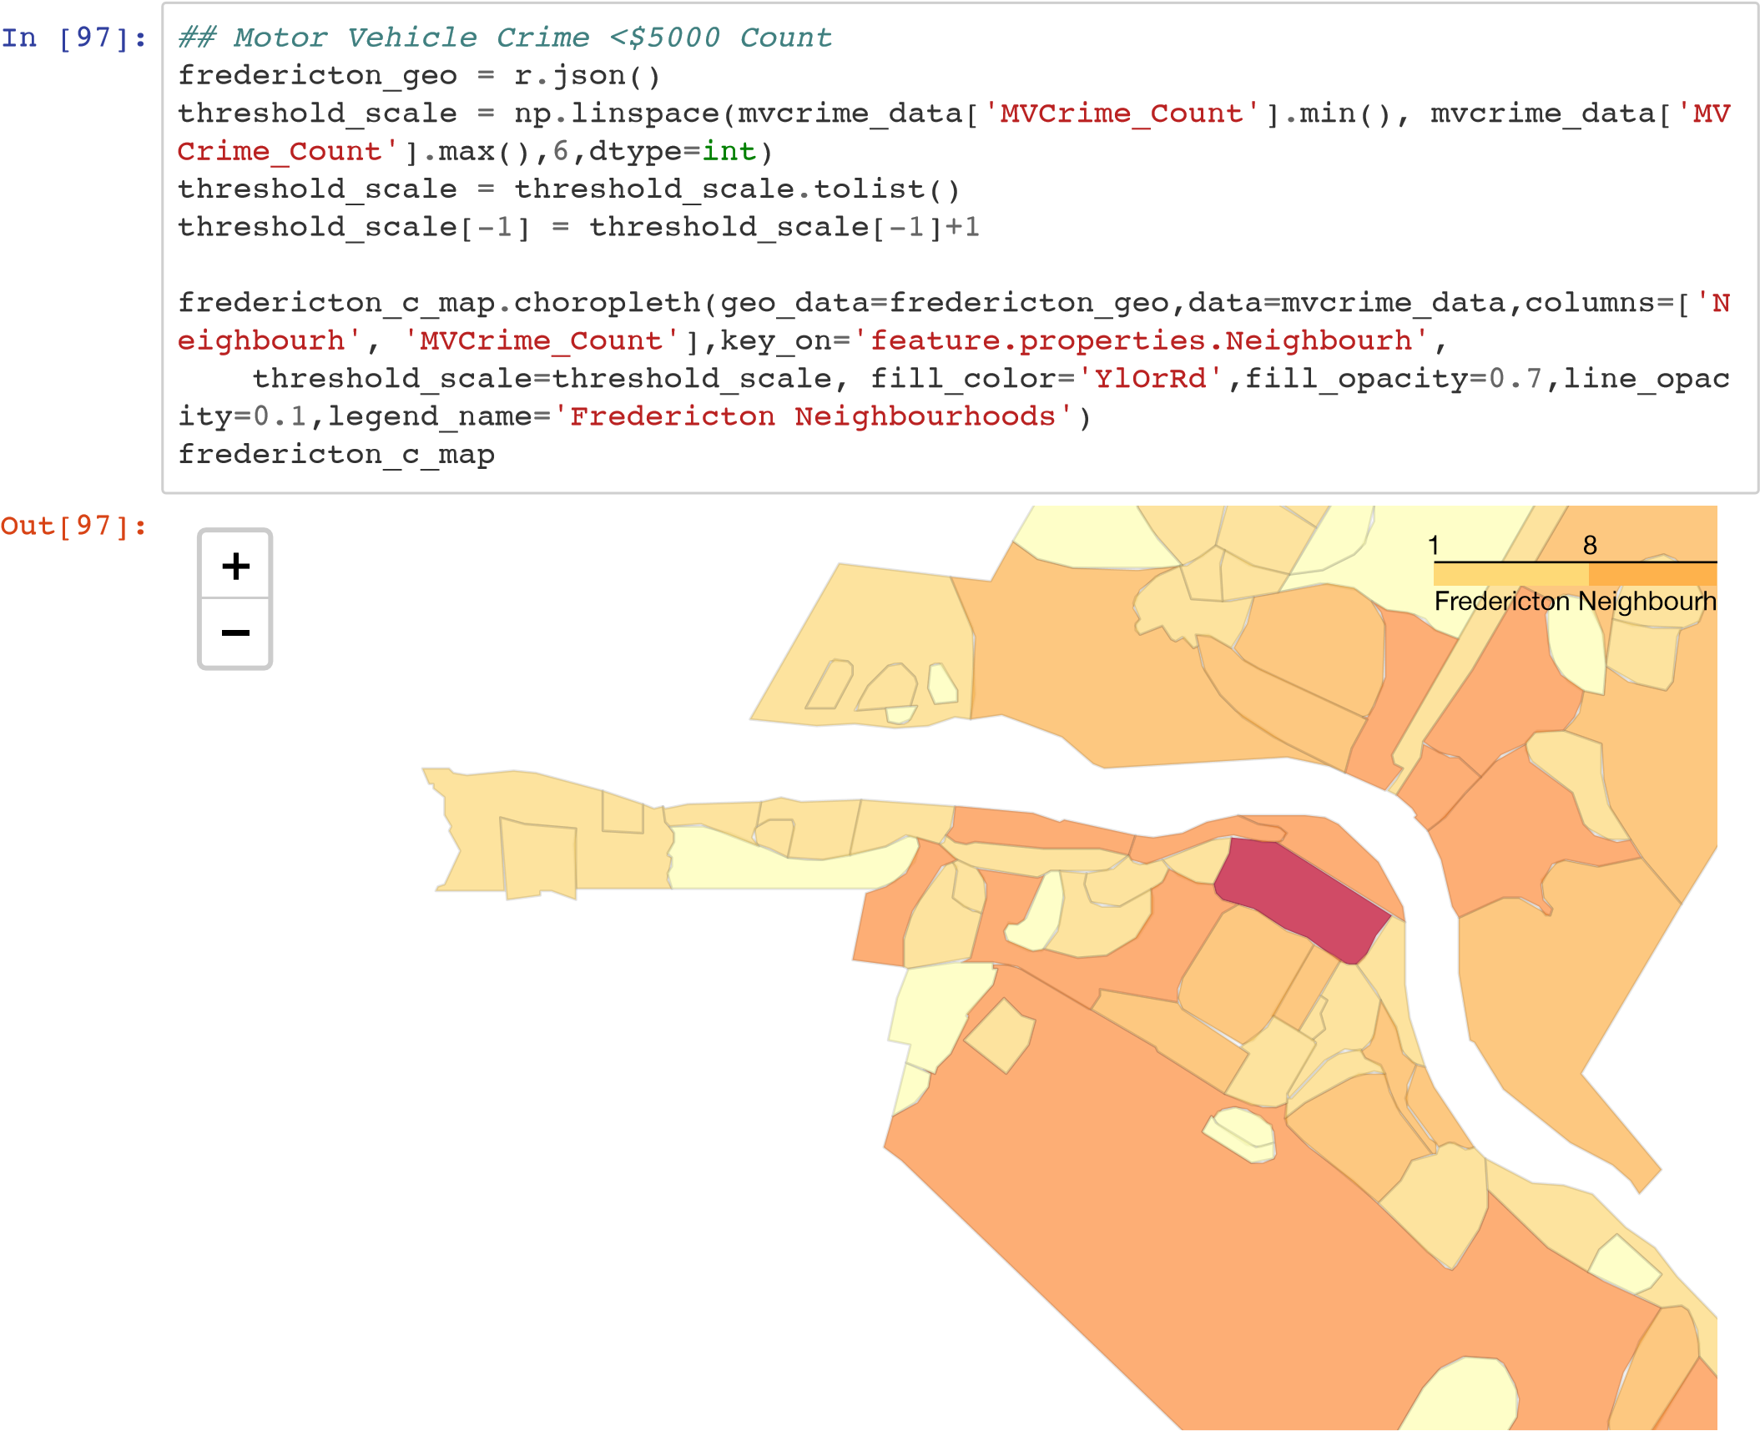

# Is it possible the higher rate of crime in the downtown area is due to population density?

In [98]:

opendemog

=

'Fredericton_Census_Tract_Demographics.xlsx'

workbook

=

pd

.

ExcelFile

(

opendemog

)

print

(

workbook

.

sheet_names

)

['Fredericton_Census_Tract_Demogr']

In [99]:

demog_df

=

workbook

.

parse

(

'Fredericton_Census_Tract_Demogr'

)

demog_df

.

head

()

Out[99]:

**FID OBJECTID DBUID DAUID CDUID CTUID CTNAME DBuid_1 DBpop2011 DBtdwell20 DB**

**0** 1 501 1310024304 13100243 1310 3200002 2 1310024304 60 25 **1** 2 502 1310032004 13100320 1310 3200010 10 1310032004 15 3

1. 3 503 1310017103 13100171 1310 3200014 14 1310017103 0 0
2. 4 504 1310018301 13100183 1310 3200012 12 1310018301 108 60

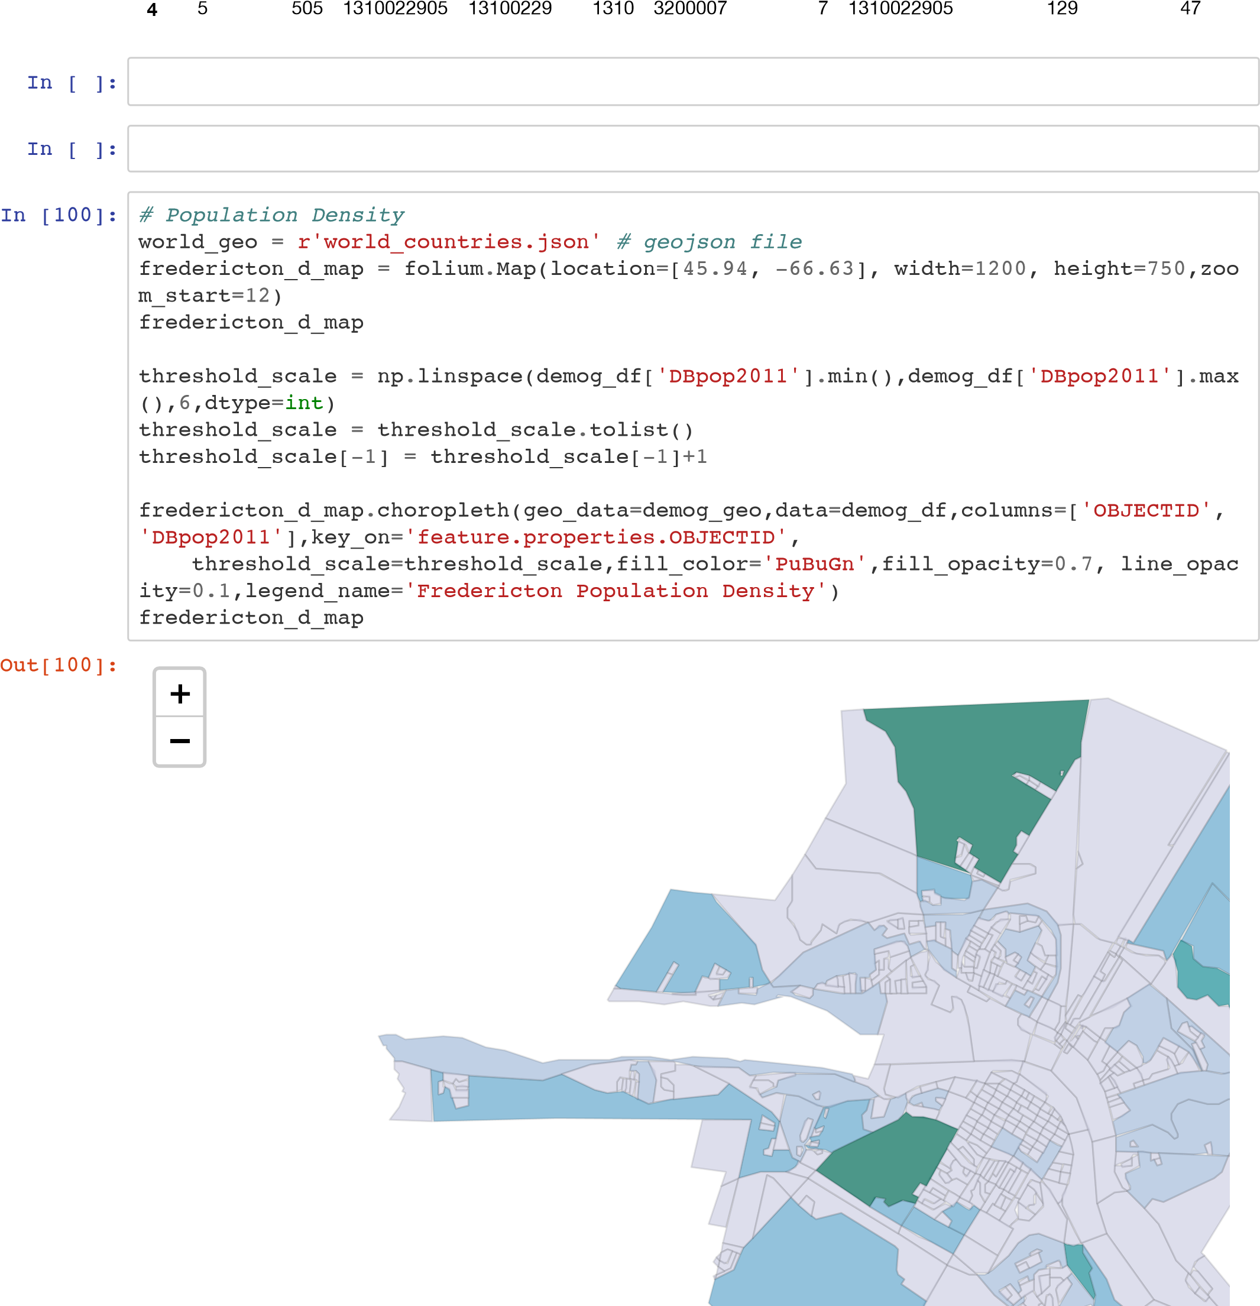

# Let's look at specific locations in Fredericton

In [101]:

pointbook

=

'Fredericton Locations.xlsx'

workbook_2

=

pd

.

ExcelFile

(

pointbook

)

print

(

workbook_2

.

sheet_names

)

[

'Sheet1'

]

In [102]:

location_df

=

workbook_2

.

parse

(

'Sheet1'

)

location_df

Out[102]:

**Location Neighbourh Latitude Longitude**

|  |  |  |  |  |
| --- | --- | --- | --- | --- |
| **0** | Knowledge Park | NaN | 45.931143 | -66.6527[1]0 |
| **1** | Fredericton Hill | NaN | 45.9485[2][3] | -66.656045 |
| **2** | Nashwaaksis | NaN | 45.98[4]382 | -66.6[5]48[6][7] |
| **3** | University of New Brunswick | NaN | 45.948121 | -66.641406 |
| **4** | Devon | NaN | 45.968802 | -66.622[8]3[9] |
| **5** | New Maryland | NaN | 45.8[10]2795 | -66.683673 |
| **6** | Marysville | NaN | 45.978913 | -66.589491 |
| **7** | Skyline Acres | NaN | 45.931827 | -66.640339 |
| **8** | Hanwell | NaN | 45.902315 | -66.755113 |
| **9** | Downtown | NaN | 45.958327 | -66.647211 |

In [103]:

location_df

.

drop

([

'Neighbourh'

]

,

axis

=

1

,

inplace

=

**True**

)

location_df

Out[103]:

**Location Latitude Longitude**

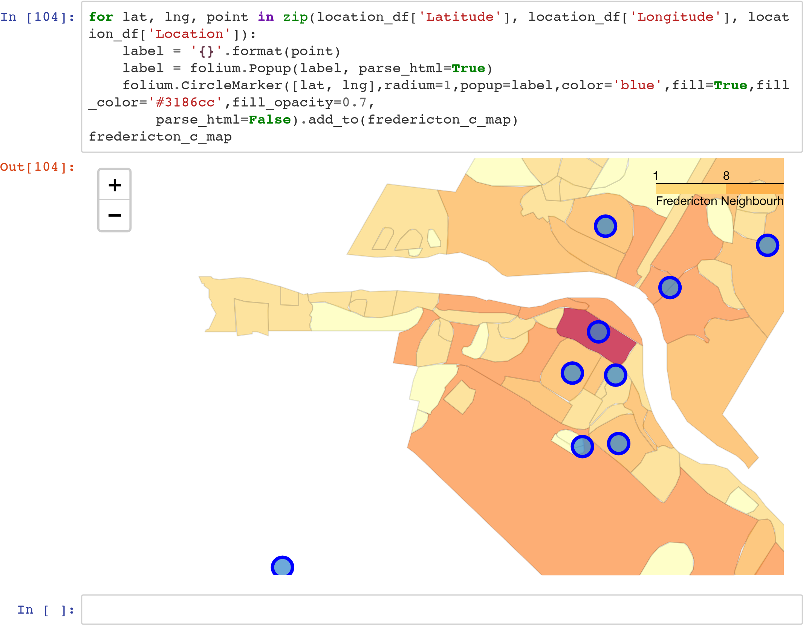

# Explore Fredericton Neighbourhoods

### Define Foursquare Credentials and Version

In [2]:

CLIENT_ID

=

'Nope'

*# your Foursquare ID*

CLIENT_SECRET

=

'Secret'

*# your Foursquare Secret*

VERSION

=

'20181201'

*# Foursquare API version*

print

(

'Your credentails:'

)

print

(

'CLIENT_ID: '

+

CLIENT_ID

)

print

(

'CLIENT_SECRET:'

+

CLIENT_SECRET

)

Your credentails:

CLIENT_ID: Nope

CLIENT_SECRET:Secret

# Let's take a look at nearby venues

In [106]: **def** getNearbyVenues(names, latitudes, longitudes, radius=1000, LIMIT=100):

venues_list=[] **for** name, lat, lng **in** zip(names, latitudes, longitudes): print(name)

*# create the API request URL*

url = 'https://api.foursquare.com/v2/venues/explore?&client_id=**{}**&client_se cret=**{}**&v=**{}**&ll=**{}**,**{}**&radius=**{}**&limit=**{}**'.format(

CLIENT_ID,

CLIENT_SECRET, VERSION, lat, lng, radius,

LIMIT)

*# make the GET request*

results = requests.get(url).json()["response"]['groups'][0]['items']

*# return only relevant information for each nearby venue* venues_list.append([( name, lat, lng, v['venue']['name'], v['venue']['id'],

v['venue']['location']['lat'], v['venue']['location']['lng'],

v['venue']['categories'][0]['name']) **for** v **in** results])

nearby_venues = pd.DataFrame([item **for** venue_list **in** venues_list **for** item **in** ve nue_list])

nearby_venues.columns = ['Location', 'Location Latitude',

'Location Longitude',

'Venue',

'Venue id',

'Venue Latitude',

'Venue Longitude',

'Venue Category'

]

**return**(nearby_venues)

In [107]: fredericton_data_venues = getNearbyVenues(names=location_df['Location'], latitudes=location_df['Latitude'], longitudes=location_df['Longitude'] )

Knowledge Park

Fredericton Hill

Nashwaaksis

University of New Brunswick

Devon

New Maryland

Marysville

Skyline Acres

Hanwell

Downtown

In [108]:

print

(

fredericton_data_venues

.

shape

)

fredericton_data_venues

(166, 8)

Out[108]:

**Location Location Location Venue Venue id Venue Venue Latitude Longitude Latitude Longitude Ca**

|  |  |  |  |  |  |  |  |  |
| --- | --- | --- | --- | --- | --- | --- | --- | --- |
| **0** | Knowledge Park | 45.931143 | -66.652700 | Costco Wholesale | 4e18ab92183880768f43bff6 | 45.927034 | -66.663447 | Ware |
| **1** | Knowledge Park | 45.931143 | -66.652700 | PetSmart | 4bbca501a0a0c9b6078f1a0f | 45.929768 | -66.659939 | Pe |
| **2** | Knowledge Park | 45.931143 | -66.652700 | Montana's | 4e50406e62844166699b0780 | 45.931511 | -66.662507 | Rest |
| **3** | Knowledge Park | 45.931143 | -66.652700 | Boston Pizza | 4b64944af964a52041bf2ae3 | 45.938123 | -66.660037 | Spo |
| **4** | Knowledge Park | 45.931143 | -66.652700 | Michaels | 4c489858417b20a13b82e1a9 | 45.929965 | -66.659548 | Arts & |
| **5** | Knowledge Park | 45.931143 | -66.652700 | Alcool NB Liquor | 4b77335df964a5202c872ee3 | 45.930680 | -66.664180 | Liquo |
| **6** | Knowledge Park | 45.931143 | -66.652700 | Best Buy | 5520124a498e0467bb6e81c8 | 45.937673 | -66.660380 | Elec |
| **7** | Knowledge Park | 45.931143 | -66.652700 | Wal-Mart | 4bad313ff964a5208c373be3 | 45.934081 | -66.663539 | B |
| **8** | Knowledge Park | 45.931143 | -66.652700 | Booster Juice | 4c42414e520fa59334f9caac | 45.935198 | -66.663602 | Sm |
| **9** | Knowledge Park | 45.931143 | -66.652700 | Dairy Queen | 4b86f05bf964a52009a731e3 | 45.938004 | -66.659442 | Fas Rest |
| **10** | Knowledge Park | 45.931143 | -66.652700 | H&M | 509c3265498efdffc5739a0f | 45.935196 | -66.663290 | C |
| **11** | Knowledge Park | 45.931143 | -66.652700 | Dairy Queen  (Treat) | 4cc6123cbde8f04d9ce0b44b | 45.934520 | -66.663988 | Fas Rest |
| **12** | Knowledge Park | 45.931143 | -66.652700 | Winners | 4caa46a744a8224b96e42640 | 45.930427 | -66.659758 | C |
| **13** | Knowledge Park | 45.931143 | -66.652700 | East Side Mario's | 4b55d89bf964a520a2f227e3 | 45.931376 | -66.663417 | Rest |
| **14** | Knowledge Park | 45.931143 | -66.652700 | McDonald's | 4c6e9ef665eda09377e951d0 | 45.934575 | -66.663319 | Fas Rest |
| **15** | Knowledge Park | 45.931143 | -66.652700 | Home Sense | 54024f60498ee424eedb7bf9 | 45.930528 | -66.660103 | Depa |
| **16** | Knowledge Park | 45.931143 | -66.652700 | The Shoe company | 4bd76dfa5cf276b0fb469b00 | 45.929636 | -66.660449 | Shoe |
| **17** | Knowledge Park | 45.931143 | -66.652700 | Avalon Spa Uptown | 4cd99e0f51fc8cfa4369f05d | 45.930774 | -66.660927 |  |
| **18** | Knowledge Park | 45.931143 | -66.652700 | Wicker Emporium | 4e6baff588772457c4fd1968 | 45.930897 | -66.661338 | Fur  Home |
| **19** | Knowledge Park | 45.931143 | -66.652700 | Dollarama | 4ba3dd18f964a520d86738e3 | 45.930897 | -66.661714 | Di |
| **20** | Knowledge Park | 45.931143 | -66.652700 | Bed Bath & Beyond | 5083f283e4b0bf87c15e9ea1 | 45.930097 | -66.662166 | Fur  Home |
| **21** | Knowledge Park | 45.931143 | -66.652700 | GAP Factory Store | 50a8f005e4b0e4f42e033a2a | 45.930211 | -66.662416 | C |
| **22** | Knowledge Park | 45.931143 | -66.652700 | carter's |  OshKosh B'gosh | 50a51363e4b0a3e2f7db76bf | 45.929978 | -66.662966 | Kids |
| **23** | Knowledge Park | 45.931143 | -66.652700 | Deluxe Fish & Chips | 4e5d0b99fa76a4cf148d9a15 | 45.931722 | -66.663131 | S  Rest |
| **24** | Knowledge | 45.931143 | -66.652700 | Hallmark | 4cd96cf651fc8cfa522eef5d | 45.930646 | -66.663745 | Gif |

Park

**Location Location Location Venue Venue id Venue Venue Latitude Longitude Latitude Longitude Ca**

|  |  |  |  |  |  |  |  |  |
| --- | --- | --- | --- | --- | --- | --- | --- | --- |
| **25** | Park | 45.931143 | -66.652700 | NB Liquor | 5985f08b6cf01a7e38b85fba | 45.930228 | -66.664395 | Liquo |
| **26** | Knowledge Park | 45.931143 | -66.652700 | Corbett Center | 57854d05498e301b3b5a4448 | 45.929733 | -66.664601 | Sh |
| **27** | Knowledge Park | 45.931143 | -66.652700 | Costco Food Court | 53693053498ef3e4ea63560f | 45.927383 | -66.663544 | Fas Rest |
| **28** | Knowledge Park | 45.931143 | -66.652700 | Sleep Country | 555b5660498eae864c440e77 | 45.929074 | -66.664605 | M |
| **29** | Knowledge Park | 45.931143 | -66.652700 | Sport Chek Regent Mall | 4ca4ecae8a65bfb717422b22 | 45.935211 | -66.663525 | Sp Goods |
| **30** | Knowledge Park | 45.931143 | -66.652700 | Rôtisserie St-Hubert | 57164569498e9bb9e88d52b0 | 45.929838 | -66.664749 | Rest |
| **31** | Fredericton  Hill | 45.948512 | -66.656045 | YMCA  Fredericton | 4e93476b8231bf0d17ba3e24 | 45.953217 | -66.649478 |  |
| **32** | Fredericton  Hill | 45.948512 | -66.656045 | 20 Twenty Club | 4c5388b0f5f3d13ac74ba5f8 | 45.951042 | -66.648112 |  |
| **33** | Fredericton  Hill | 45.948512 | -66.656045 | Shoppers Drug Mart | 4fb699dc7bebbeb2a6c7ba88 | 45.942627 | -66.655523 | Pha |
| **34** | Fredericton  Hill | 45.948512 | -66.656045 | Subway | 4bae3571f964a52076923be3 | 45.940931 | -66.657445 | San |
| **35** | Fredericton  Hill | 45.948512 | -66.656045 | Canadian  Tire | 4bb52ba72ea19521201caa2f | 45.944409 | -66.666820 | Ha |
| **36** | Fredericton  Hill | 45.948512 | -66.656045 | Tim Hortons | 4dc29f89d4c07da169fbf84b | 45.943720 | -66.646907 | Coffee |
| **37** | Fredericton  Hill | 45.948512 | -66.656045 | The Aitken  University  Centre -  UNB | 4b6458eff964a52052ac2ae3 | 45.941644 | -66.663667 | H |
| **38** | Fredericton  Hill | 45.948512 | -66.656045 | Queen Square Park | 4b7acb0ef964a520113d2fe3 | 45.950961 | -66.648245 |  |
| **39** | Fredericton  Hill | 45.948512 | -66.656045 | Great  Canadian Bagel | 4b784edbf964a52013c42ee3 | 45.941040 | -66.657545 |  |
| **40** | Fredericton  Hill | 45.948512 | -66.656045 | Monkey Cakes | 4ec147368231b62f43026067 | 45.940938 | -66.657346 |  |
| **41** | Fredericton  Hill | 45.948512 | -66.656045 | Papa John's Pizza | 4ecc29f59adfd1f5b5c7bbb1 | 45.956655 | -66.657285 | Pizza |
| **42** | Fredericton  Hill | 45.948512 | -66.656045 | Greco | 4cfc0660c51fa1cdd3d7e92b | 45.954055 | -66.647290 | Pizza |
| **43** | Fredericton  Hill | 45.948512 | -66.656045 | Dick's  Grocery Store | 4c545e5db426ef3b11cc7e8a | 45.941957 | -66.663877 | Smoke |
| **44** | Fredericton  Hill | 45.948512 | -66.656045 | Tingley's Ice  Cream | 4c13c001b7b9c9284e12aa37 | 45.957087 | -66.655855 | Ice |
| **45** | Fredericton  Hill | 45.948512 | -66.656045 | Domino's Pizza | 50f9bbc75d24acebc259244d | 45.957177 | -66.656638 | Pizza |
| **46** | Fredericton  Hill | 45.948512 | -66.656045 | Jumbo Video | 4bc0d29a920eb71307a2192c | 45.957286 | -66.656312 | Video |
| **47** | Fredericton  Hill | 45.948512 | -66.656045 | Goody Shop | 4b8580edf964a5201d6231e3 | 45.951172 | -66.644000 |  |
| **48** | Nashwaaksis | 45.983382 | -66.644856 | Peters Meat, Seafood & | 4c4e04ecfb742d7fe7bba62d | 45.976652 | -66.649765 | G |

Knowledge

Lobster Market **Location Location Location Venue Venue id Venue Venue Latitude Longitude Latitude Longitude Ca**

|  |  |  |  |  |  |  |  |  |
| --- | --- | --- | --- | --- | --- | --- | --- | --- |
| **49** | Nashwaaksis | 45.983382 | -66.644856 | Tim Hortons | 4b742f31f964a520b7cb2de3 | 45.975294 | -66.646977 | Coffee |
| **50** | Nashwaaksis | 45.983382 | -66.644856 | The  Northside Market | 50270b2ae4b042eaf816ee61 | 45.977779 | -66.635003 | F |
| **51** | Nashwaaksis | 45.983382 | -66.644856 | Shoppers Drug Mart | 4c745e08db52b1f781f775dc | 45.976515 | -66.648534 | Pha |
| **52** | Nashwaaksis | 45.983382 | -66.644856 | Subway | 4bc5db23693695213a9a8488 | 45.976886 | -66.648661 | San |
| **53** | Nashwaaksis | 45.983382 | -66.644856 | Subway | 4c87f3b4bf40a1cd09fd08b4 | 45.989114 | -66.652061 | San |
| **54** | Nashwaaksis | 45.983382 | -66.644856 | Kentucky  Fried Chicken | 4eefb90ba69ddc7bcb336081 | 45.975903 | -66.646846 | Fas Rest |
| **55** | Nashwaaksis | 45.983382 | -66.644856 | Nashwaaksis Field House | 4b73436cf964a52016a52de3 | 45.984849 | -66.643635 |  |
| **56** | Nashwaaksis | 45.983382 | -66.644856 | KFC | 4c9267139199bfb7786c14df | 45.975907 | -66.646870 | Fas Rest |
| **57** | Nashwaaksis | 45.983382 | -66.644856 | Tim Hortons | 4c0104cf360a9c74bb11d9a0 | 45.989221 | -66.652208 | Coffee |
| **58** | Nashwaaksis | 45.983382 | -66.644856 | Thai spice | 503658e5e4b00b386cc5d972 | 45.975890 | -66.647424 | Rest |
| **59** | Nashwaaksis | 45.983382 | -66.644856 | Mike's Old  Fashioned Bakery | 4d67fde7709bb60c5eacb014 | 45.976560 | -66.650030 |  |
| **60** | Nashwaaksis | 45.983382 | -66.644856 | Cox  Electronics | 4d07eab6611ff04d4f4718fb | 45.976112 | -66.649222 | Elec |
| **61** | Nashwaaksis | 45.983382 | -66.644856 | A Pile Of Scrap! | 4e9f0e9b93ad5d11f3d36ba1 | 45.984398 | -66.633329 | Arts & |
| **62** | Nashwaaksis | 45.983382 | -66.644856 | Jim Gilberts  Wheels And Deals | 4b9a7ef5f964a520b6ba35e3 | 45.980784 | -66.633311 | Dea |
| **63** | Nashwaaksis | 45.983382 | -66.644856 | Trailway Brewery | 574a1b86cd10af189e38500e | 45.975442 | -66.649496 | Bee |
| **64** | Nashwaaksis | 45.983382 | -66.644856 | The North Side Market | 501c19f7e4b01c57ff1b1212 | 45.977837 | -66.635168 | F |
| **65** | Nashwaaksis | 45.983382 | -66.644856 | Avalon SalonSpa | 4bc31784920eb71312ec1c2c | 45.974591 | -66.644756 |  |
| **66** | Nashwaaksis | 45.983382 | -66.644856 | Tony Pepperoni | 4c88f56dbbec6dcbe9f2d758 | 45.991888 | -66.648599 | Pizza |
|  | University of |  |  | The Richard J. CURRIE |  |  |  | Bas |

**67** New 45.948121 -66.641406 Center - 4dbae5806e815ab0de5d2637 45.946698 -66.637891

Brunswick

UNB

University of Charlotte

|  |  |  |  |  |  |  |  |  |
| --- | --- | --- | --- | --- | --- | --- | --- | --- |
| **68** | New  Brunswick | 45.948121 | -66.641406 | Street Arts Centre | 4b7f0318f964a5203d1030e3 | 45.955620 | -66.639324 | Art |
| **69** | University of  New | 45.948121 | -66.641406 | Sobeys | 4b6727daf964a520493e2be3 | 45.954891 | -66.645920 | G |

Brunswick

University of

1. New 45.948121 -66.641406 FredeYrMictCoAn 4e93476b8231bf0d17ba3e24 45.953217 -66.649478

Brunswick

University of

1. New 45.948121 -66.641406 20 TwCelnutby 4c5388b0f5f3d13ac74ba5f8 45.951042 -66.648112

Brunswick

**Location Location Location Venue Venue id Venue Venue Latitude Longitude Latitude Longitude Ca**

|  |  |  |  |  |  |  |  |  |
| --- | --- | --- | --- | --- | --- | --- | --- | --- |
| **72** | New  Brunswick | 45.948121 | -66.641406 | Pub & Grill -  UNB | 4b7ac93ef964a520b53c2fe3 | 45.945434 | -66.641626 |  |
| **73** | University of  New  Brunswick | 45.948121 | -66.641406 | Harvey's | 4bbdff85f57ba59320bdaeb9 | 45.953544 | -66.645021 | Burge |
| **74** | University of  New  Brunswick | 45.948121 | -66.641406 | Tim Hortons | 4c865c1774d7b60c3f41a3d8 | 45.945185 | -66.641545 | Coffee |
| **75** | University of  New  Brunswick | 45.948121 | -66.641406 | Tim Hortons | 4dc29f89d4c07da169fbf84b | 45.943720 | -66.646907 | Coffee |
| **76** | University of  New  Brunswick | 45.948121 | -66.641406 | College Hill Social Club | 4b7aca23f964a520df3c2fe3 | 45.945162 | -66.641472 |  |
| **77** | Devon | 45.968802 | -66.622738 | New  England Pizza | 4c09984e7e3fc928b64bf282 | 45.967675 | -66.629905 | Pizza |
| **78** | Devon | 45.968802 | -66.622738 | Wolastoq Wharf | 4fbaafb0e4b0c7f68a419500 | 45.969975 | -66.632568 | S  Rest |
| **79** | Devon | 45.968802 | -66.622738 | Dairy Queen | 4c5cab2894fd0f473c69c945 | 45.969077 | -66.632059 | Fas Rest |
| **80** | Devon | 45.968802 | -66.622738 | Pharmacie Jean Coutu | 4eb9523077c8972738ac89b2 | 45.967766 | -66.630551 | Pha |
| **81** | Devon | 45.968802 | -66.622738 | Tim Hortons | 4b5b0812f964a520d8df28e3 | 45.969381 | -66.632730 | Coffee |
| **82** | Devon | 45.968802 | -66.622738 | Henry Park | 4c8e283dad01199c7923726d | 45.963992 | -66.620283 | Ba |
| **83** | Devon | 45.968802 | -66.622738 | Giant Tiger | 4c95354f58d4b60c80443029 | 45.967715 | -66.630410 | Depa |
| **84** | Devon | 45.968802 | -66.622738 | york arena | 4b6c4f10f964a520792f2ce3 | 45.964888 | -66.617110 | Skatin |
| **85** | Devon | 45.968802 | -66.622738 | St. Mary's Supermarket | 4b9fa6adf964a520c93137e3 | 45.971945 | -66.631248 | G |
| **86** | Devon | 45.968802 | -66.622738 | Dixie Lee | 4c5cacc5d25320a103fdc37a | 45.962257 | -66.624952 | Fas Rest |
| **87** | Devon | 45.968802 | -66.622738 | St Marys Smoke Shop | 4ebddf8a4690d233887bf4a6 | 45.972270 | -66.631348 | Smoke |
| **88** | Devon | 45.968802 | -66.622738 | Carleton Park | 4bce2eeb29d4b7138521a8dc | 45.961182 | -66.626310 |  |
| **89** | New  Maryland | 45.892795 | -66.683673 | New York Fries | 4d8771fc651041bd194d9b30 | 45.890420 | -66.683580 | Fas Rest |
| **90** | New  Maryland | 45.892795 | -66.683673 | Centre De  Danse Roca  Dance Center | 55fdfc2b498ed76a0f7aa3f6 | 45.890978 | -66.692237 |  |
| **91** | New  Maryland | 45.892795 | -66.683673 | Baseball,  Basketball,  Tennis and  Hockey In One... | 4e48415862e148603b8b3fc2 | 45.890726 | -66.692814 | Ba |
| **92** | New  Maryland | 45.892795 | -66.683673 | Circle K | 4b9e633ef964a5202fdf36e3 | 45.885412 | -66.688995 | Gas S |
| **93** | Marysville | 45.978913 | -66.589491 | Tim Hortons | 4baa1b40f964a520174b3ae3 | 45.978193 | -66.593041 | Coffee |
| **94** | Marysville | 45.978913 | -66.589491 | Royals Field | 4c573f916201e21edff8736e | 45.980267 | -66.588412 | Ba |

University of The Cellar

S

**Location Location Location Venue Venue id Venue Venue Latitude Longitude Latitude Longitude Ca**

|  |  |  |  |  |  |  |  |  |
| --- | --- | --- | --- | --- | --- | --- | --- | --- |
| **95** | Marysville | 45.978913 | -66.589491 | Pharmacy | 4c8bee978018a1cdd1f2e7d2 | 45.980194 | -66.588628 | Pha |
| **96** | Marysville | 45.978913 | -66.589491 | Marysville Place | 4ce6d19be1eeb60c512d99ae | 45.980243 | -66.588277 |  |
| **97** | Marysville | 45.978913 | -66.589491 | Circle K | 4bb88fe853649c74431847fb | 45.979250 | -66.593232 | Gas S |
| **98** | Skyline Acres | 45.931827 | -66.640339 | Grant Harvey Centre | 4f915a7ee4b01406ebc873ae | 45.925002 | -66.641004 | H |
| **99** | Skyline Acres | 45.931827 | -66.640339 | Kimble Field | 4fdaa8c2e4b08f3358b1b3d1 | 45.930535 | -66.631233 | Ba |
| **100** | Skyline Acres | 45.931827 | -66.640339 | Mandarin Palace | 4b786998f964a5204ecc2ee3 | 45.935440 | -66.631007 | C  Rest |
| **101** | Skyline Acres | 45.931827 | -66.640339 | Oriental Pearl | 4ec68431775bf65c02417199 | 45.930085 | -66.629518 | C  Rest |
| **102** | Hanwell | 45.902315 | -66.755113 | Advanced Fabrics | 53c133a4498e933c415c6118 | 45.905297 | -66.750944 | S |
| **103** | Hanwell | 45.902315 | -66.755113 | Country Style | 56356c83498e17f8ed69a380 | 45.905937 | -66.751084 | Coffee |
| **104** | Downtown | 45.958327 | -66.647211 | Cafe Loka & Bistro | 4e70d116152073dd03c2c50e | 45.957570 | -66.647978 |  |
| **105** | Downtown | 45.958327 | -66.647211 | Boyce  Farmers Market | 4b5163b4f964a5204d4c27e3 | 45.958354 | -66.639654 | F |
| **106** | Downtown | 45.958327 | -66.647211 | Second Cup | 4b7067c6f964a5205a182de3 | 45.961385 | -66.642372 | Coffee |
| **107** | Downtown | 45.958327 | -66.647211 | Lunar Rogue | 4b8c53e7f964a520d4ca32e3 | 45.959998 | -66.639116 |  |
| **108** | Downtown | 45.958327 | -66.647211 | Jonnie Java Roasters | 4bc47e80920eb71369c71e2c | 45.962226 | -66.643852 | Coffee |
| **109** | Downtown | 45.958327 | -66.647211 | Picaroon's Brewtique | 4ced5cfe7b943704ea782653 | 45.962701 | -66.642731 | B |
| **110** | Downtown | 45.958327 | -66.647211 | Sobeys | 4b6727daf964a520493e2be3 | 45.954891 | -66.645920 | G |
| **111** | Downtown | 45.958327 | -66.647211 | Luna Pizza | 4be47e9b2468c92811dbfe42 | 45.962246 | -66.643788 | Rest |
| **112** | Downtown | 45.958327 | -66.647211 | Palate  Restaurant & Cafe | 4c2e0e6ae760c9b69bdf4549 | 45.962338 | -66.641776 | Rest |
| **113** | Downtown | 45.958327 | -66.647211 | Alcool NB Liquor | 4d9a52120d5f224bc5f7a34e | 45.956140 | -66.647558 | Liquo |
| **114** | Downtown | 45.958327 | -66.647211 | coffee and friends | 4b533f74f964a520009427e3 | 45.961842 | -66.643479 | Coffee |
| **115** | Downtown | 45.958327 | -66.647211 | Chess Piece  Pâtisserie & Cafe | 53c00bcc498e1f34dc3687ae | 45.963354 | -66.644017 |  |
| **116** | Downtown | 45.958327 | -66.647211 | Victory Meat Market | 4bd1ffd341b9ef3bcb19fde5 | 45.962661 | -66.645820 | G |
| **117** | Downtown | 45.958327 | -66.647211 | Exhibition Grounds | 4c76d45d07818cfafe94d2e3 | 45.960078 | -66.655522 | Rac |
| **118** | Downtown | 45.958327 | -66.647211 | The Abbey  Café & Gallery | 57178722498e4222f7d5b298 | 45.961301 | -66.640188 |  |
| **119** | Downtown | 45.958327 | -66.647211 | Charlotte  Street Arts Centre | 4b7f0318f964a5203d1030e3 | 45.955620 | -66.639324 | Art |
| **120** | Downtown | 45.958327 | -66.647211 | Isaac's Way | 51c8a824498ef33c708ac9e9 | 45.960944 | -66.637796 | Rest |

Northside

**Location Location Location Venue Venue id Venue Venue Latitude Longitude Latitude Longitude Ca**

|  |  |  |  |  |  |  |  |  |
| --- | --- | --- | --- | --- | --- | --- | --- | --- |
| **121** | Downtown | 45.958327 | -66.647211 | Fredericton | 4e93476b8231bf0d17ba3e24 | 45.953217 | -66.649478 |  |
| **122** | Downtown | 45.958327 | -66.647211 | Read's News Stand | 4b4b6bf2f964a5200a9b26e3 | 45.961859 | -66.643464 | Coffee |
| **123** | Downtown | 45.958327 | -66.647211 | King Street Ale House | 5283fd1c498e138a8297590c | 45.960460 | -66.641012 |  |
| **124** | Downtown | 45.958327 | -66.647211 | 540 Kitchen and Bar | 53ab370e498e91a454f49e67 | 45.961657 | -66.640152 | Gas |
| **125** | Downtown | 45.958327 | -66.647211 | Dimitri's Souvlaki | 4bacf7e8f964a520571f3be3 | 45.963093 | -66.644479 | Rest |
| **126** | Downtown | 45.958327 | -66.647211 | Smoke's Poutinerie | 51756ac6498ece19b79a31f6 | 45.962032 | -66.644021 | Fas Rest |
| **127** | Downtown | 45.958327 | -66.647211 | Snooty Fox | 4b4ca053f964a52006b826e3 | 45.960794 | -66.638927 |  |
| **128** | Downtown | 45.958327 | -66.647211 | Officer's Square | 4c83b0df2f1c236a4bc54443 | 45.961754 | -66.639084 |  |
| **129** | Downtown | 45.958327 | -66.647211 | Fredericton Playhouse | 4b516b64f964a520df4c27e3 | 45.960101 | -66.636969 | Perf Arts |
| **130** | Downtown | 45.958327 | -66.647211 | Willie O'Ree Place | 4b76879ef964a520a5502ee3 | 45.963017 | -66.646100 | H |
| **131** | Downtown | 45.958327 | -66.647211 | The Joyce | 4b624863f964a5203b402ae3 | 45.960309 | -66.636806 |  |
| **132** | Downtown | 45.958327 | -66.647211 | Cora's  Breakfast & Lunch | 4b8130c7f964a520e99930e3 | 45.962282 | -66.641607 | Bre |
| **133** | Downtown | 45.958327 | -66.647211 | Strange Adventures | 4babdcbdf964a5200cd03ae3 | 45.962733 | -66.643315 | Hobby |
| **134** | Downtown | 45.958327 | -66.647211 | Naru  Japanese Cuisine | 50461342e4b0c55b9639accc | 45.961721 | -66.640125 | Rest |
| **135** | Downtown | 45.958327 | -66.647211 | Mexicali Rosas | 4c65dd9a19f3c9b697769eff | 45.962811 | -66.646079 | M  Rest |
| **136** | Downtown | 45.958327 | -66.647211 | Brewbakers | 4b6754faf964a5208d482be3 | 45.960703 | -66.640935 | Rest |
| **137** | Downtown | 45.958327 | -66.647211 | Dolan's Pub | 4b516ddbf964a520144d27e3 | 45.962886 | -66.644615 |  |
| **138** | Downtown | 45.958327 | -66.647211 | Beaverbrook Art Gallery | 4c13a7f7b7b9c92865dea937 | 45.959878 | -66.635858 | Art M |
| **139** | Downtown | 45.958327 | -66.647211 | McGinnis Landing | 4b6df601f964a5203d9f2ce3 | 45.963013 | -66.646536 | Steak |
| **140** | Downtown | 45.958327 | -66.647211 | Atlantic Superstore | 4b5b0a91f964a5205fe028e3 | 45.958260 | -66.658048 | Super |
| **141** | Downtown | 45.958327 | -66.647211 | 20 Twenty Club | 4c5388b0f5f3d13ac74ba5f8 | 45.951042 | -66.648112 |  |
| **142** | Downtown | 45.958327 | -66.647211 | Geek Chic | 4b516f03f964a520324d27e3 | 45.960573 | -66.639225 | Toy / |
| **143** | Downtown | 45.958327 | -66.647211 | Wilser's  Room | 4ba01983f964a520f15937e3 | 45.963192 | -66.644089 |  |
| **144** | Downtown | 45.958327 | -66.647211 | Tim Hortons | 4b6455b0f964a52067ab2ae3 | 45.959873 | -66.639259 | Coffee |
| **145** | Downtown | 45.958327 | -66.647211 | TD Canada  Trust | 4b6d8261f964a52022792ce3 | 45.963891 | -66.645782 |  |
| **146** | Downtown | 45.958327 | -66.647211 | Fit4Less | 4c9381ab94a0236a70ac8312 | 45.958634 | -66.657319 | F |
| **147** | Downtown | 45.958327 | -66.647211 | Harvey's | 4bbdff85f57ba59320bdaeb9 | 45.953544 | -66.645021 | Burge |

YMCA

**Location Location Location Venue Venue id Venue Venue Latitude Longitude Latitude Longitude Ca**

|  |  |  |  |  |  |  |  |  |
| --- | --- | --- | --- | --- | --- | --- | --- | --- |
| **148** | Downtown | 45.958327 | -66.647211 | Drug Mart | 4db07df34df03036e8bbb640 | 45.961351 | -66.644493 | Pha |
| **149** | Downtown | 45.958327 | -66.647211 | Shan | 4dfb6fc31f6eeef806aacc25 | 45.961818 | -66.643706 | C  Rest |
| **150** | Downtown | 45.958327 | -66.647211 | bulgogi | 4b605f0ff964a5203de229e3 | 45.961522 | -66.642742 | K  Rest |
| **151** | Downtown | 45.958327 | -66.647211 | William's Seafood | 4b7c26f5f964a52061802fe3 | 45.959296 | -66.655663 | S  Rest |
| **152** | Downtown | 45.958327 | -66.647211 | Subway | 4b6b883df964a5205a0e2ce3 | 45.962580 | -66.645032 | San |
| **153** | Downtown | 45.958327 | -66.647211 | Capital Complex | 4b6faa7cf964a52073f92ce3 | 45.963245 | -66.644123 |  |
| **154** | Downtown | 45.958327 | -66.647211 | boom! Nightclub | 4ba240eef964a52050e737e3 | 45.962315 | -66.641645 | Nig |
| **155** | Downtown | 45.958327 | -66.647211 | Tim Hortons | 4ba8bdb3f964a5204ceb39e3 | 45.959933 | -66.655493 | Coffee |
| **156** | Downtown | 45.958327 | -66.647211 | King's Place  Mall | 4bc61ba4d35d9c74292de23a | 45.961679 | -66.643267 | Sh |
| **157** | Downtown | 45.958327 | -66.647211 | Running Room | 4c6d4adb23c1a1cdffc81bcf | 45.961812 | -66.643510 | Sp Goods |
| **158** | Downtown | 45.958327 | -66.647211 | The Happy Baker | 4b703d21f964a5204c0d2de3 | 45.960536 | -66.641465 |  |
| **159** | Downtown | 45.958327 | -66.647211 | Owl's Nest Bookstore | 4d6ea0c98df1548152778123 | 45.963051 | -66.643872 | Boo |
| **160** | Downtown | 45.958327 | -66.647211 | Tingley's Ice  Cream | 4c13c001b7b9c9284e12aa37 | 45.957087 | -66.655855 | Ice |
| **161** | Downtown | 45.958327 | -66.647211 | Jumbo Video | 4bc0d29a920eb71307a2192c | 45.957286 | -66.656312 | Video |
| **162** | Downtown | 45.958327 | -66.647211 | Enterprise Rent-A-Car | 4d3ae3edbf6d5481b26fd1e1 | 45.957743 | -66.656527 | Ren Lo |
| **163** | Downtown | 45.958327 | -66.647211 | Domino's Pizza | 50f9bbc75d24acebc259244d | 45.957177 | -66.656638 | Pizza |
| **164** | Downtown | 45.958327 | -66.647211 | Papa John's | 4ecc29f59adfd1f5b5c7bbb1 | 45.956655 | -66.657285 | Pizza |

Shoppers

Pizza

In [109]:

print

(

'There are

**{}**

unique venue categories.'

.

format

(

len

(

fredericton_data_venues

[

'V

enue Category'

]

.

unique

())))

**1**

**6**

**5**

D

o

w

n

t

o

w

n

4

5

.

9

5

8

3

2

7

-

6

6

.

6

4

7

2

1

1

Q

u

e

e

n

S

q

u

a

r

e

P

a

r

k

4

b

7

a

c

b

0

e

f

9

6

4

a

5

2

0

1

1

3

d

2

f

e

3

4

5

.

9

5

0

9

6

1

-

6

6

.

6

4

8

2

4

5

There are 73 unique venue categories.



In [110]: print('There are **{}** unique venues.'.format(len(fredericton_data_venues['Venue id']. unique())))

There are 153 unique venues.

In [111]: univen = fredericton_data_venues.groupby('Location').nunique('Venue Category') univen

Out[111]:

|  |  |  |  |  |  |  |  |
| --- | --- | --- | --- | --- | --- | --- | --- |
| **Location** | **Location Latitude** | **Location Longitude** | **Venue** | **Venue**  **id** | **Venue Latitude** | **Venue**  **Longitude** | **Venue**  **Category** |

**Location**

**Devon** 1 1 1 12 12 12 12 11

**Downtown** 1 1 1 61 62 62 62 44

**Fredericton Hill** 1 1 1 17 17 17 17 13

**Hanwell** 1 1 1 2 2 2 2 2

**Knowledge Park** 1 1 1 31 31 31 31 23

**Marysville** 1 1 1 5 5 5 5 5

**Nashwaaksis** 1 1 1 17 19 19 19 15

**New Maryland** 1 1 1 4 4 4 4 4

**Skyline Acres** 1 1 1 4 4 4 4 3

**University of New** 1 1 1 9 10 10 10 8

**Brunswick**

In [112]: fredericton_data_venues.groupby('Venue Category').nunique()

Out[112]:

|  |  |  |  |  |  |  |  |
| --- | --- | --- | --- | --- | --- | --- | --- |
| **Location** | **Location Latitude** | **Location Longitude** | **Venue** | **Venue**  **id** | **Venue Latitude** | **Venue**  **Longitude** | **Venue**  **Category** |

**Venue Category**

**Art Gallery** 2 2 2 1 1 1 1 1

**Art Museum** 1 1 1 1 1 1 1 1

**Arts & Crafts** 2 2 2 2 2 2 2 1

**Store**

**Auto Dealership** 1 1 1 1 1 1 1 1

**Bakery** 3 3 3 5 5 5 5 1

**Bank** 1 1 1 1 1 1 1 1

**Bar** 3 3 3 4 4 4 4 1

**Baseball Field** 3 3 3 3 3 3 3 1

**Baseball Stadium** 1 1 1 1 1 1 1 1

**Basketball Court** 1 1 1 1 1 1 1 1

**Beer Store** 1 1 1 1 1 1 1 1

**Big Box Store** 1 1 1 1 1 1 1 1

**Bookstore** 1 1 1 1 1 1 1 1

**Breakfast Spot** 1 1 1 1 1 1 1 1

**Brewery** 1 1 1 1 1 1 1 1

**Burger Joint** 2 2 2 1 1 1 1 1

**Café** 1 1 1 3 3 3 3 1

**Chinese** 2 2 2 3 3 3 3 1

**Restaurant**

**Clothing Store** 1 1 1 3 3 3 3 1

**Coffee Shop** 7 7 7 6 13 13 13 1

**Dance Studio** 1 1 1 1 1 1 1 1

**Department Store** 2 2 2 2 2 2 2 1

**Discount Store** 1 1 1 1 1 1 1 1

**Electronics Store** 2 2 2 2 2 2 2 1

**Farmers Market** 2 2 2 3 3 3 3 1

**Fast Food** 5 5 5 9 10 10 10 1

**Restaurant**

**Furniture / Home** 1 1 1 2 2 2 2 1

**Store**

**Gas Station** 2 2 2 1 2 2 2 1

**Gastropub** 1 1 1 1 1 1 1 1

**Gift Shop** 1 1 1 1 1 1 1 1

**Greek Restaurant** 1 1 1 1 1 1 1 1

**Grocery Store** 4 4 4 4 4 4 4 1

**Gym** 4 4 4 2 2 2 2 1

**Gym / Fitness** 1 1 1 1 1 1 1 1

**Center**

|  |  |  |  |  |  |  |  |
| --- | --- | --- | --- | --- | --- | --- | --- |
| **Location** | **Location Latitude** | **Location Longitude** | **Venue** | **Venue**  **id** | **Venue Latitude** | **Venue**  **Longitude** | **Venue**  **Category** |

**Venue Category**

**Hardware Store** 1 1 1 1 1 1 1 1

**Hobby Shop** 1 1 1 1 1 1 1 1

**Hockey Arena** 3 3 3 3 3 3 3 1

**Ice Cream Shop** 2 2 2 1 1 1 1 1

**Italian Restaurant** 2 2 2 2 2 2 2 1

**Kids Store** 1 1 1 1 1 1 1 1

**Korean** 1 1 1 1 1 1 1 1

**Restaurant**

**Liquor Store** 2 2 2 2 3 3 3 1

**Mattress Store** 1 1 1 1 1 1 1 1

**Mexican** 1 1 1 1 1 1 1 1

**Restaurant**

**Nightclub** 1 1 1 1 1 1 1 1

**Park** 4 4 4 4 4 4 4 1

**Performing Arts** 1 1 1 1 1 1 1 1

**Venue**

**Pet Store** 1 1 1 1 1 1 1 1

**Pharmacy** 5 5 5 3 5 5 5 1

**Pizza Place** 4 4 4 5 5 5 5 1

**Pub** 2 2 2 6 6 6 6 1

**Racetrack** 1 1 1 1 1 1 1 1

**Rental Car** 1 1 1 1 1 1 1 1

**Location**

**Rental Service** 1 1 1 1 1 1 1 1

**Restaurant** 2 2 2 5 5 5 5 1

**Sandwich Place** 3 3 3 1 4 4 4 1

**Seafood** 3 3 3 3 3 3 3 1

**Restaurant**

**Shoe Store** 1 1 1 1 1 1 1 1

**Shopping Mall** 1 1 1 1 1 1 1 1

**Shopping Plaza** 1 1 1 1 1 1 1 1

**Skating Rink** 1 1 1 1 1 1 1 1

**Smoke Shop** 2 2 2 2 2 2 2 1

**Smoothie Shop** 1 1 1 1 1 1 1 1

**Spa** 2 2 2 2 2 2 2 1

**Sporting Goods** 2 2 2 2 2 2 2 1

**Shop**

**Sports Bar** 1 1 1 1 1 1 1 1

**Steakhouse** 1 1 1 1 1 1 1 1

**Supermarket** 1 1 1 1 1 1 1 1 **Location Location Location Venue Venue Venue Venue Venue Latitude Longitude id Latitude Longitude Category**

**Venue Category**

**Sushi Restaurant** 1 1 1 1 1 1 1 1

**Thai Restaurant** 1 1 1 1 1 1 1 1

**Toy / Game Store** 1 1 1 1 1 1 1 1

**Video Store** 2 2 2 1 1 1 1 1

**Warehouse Store** 1 1 1 1 1 1 1 1

In [ ]:

# Analyze each Location

In [113]: *# one hot encoding* freddy_onehot = pd.get_dummies(fredericton_data_venues[['Venue Category']], prefix=

"", prefix_sep="")

*# add neighbourhood column back to dataframe*

freddy_onehot['Location'] = fredericton_data_venues['Location']

*# move neighbourhood column to the first column*

fixed_columns = [freddy_onehot.columns[-1]] + list(freddy_onehot.columns[:-1]) freddy_onehot = freddy_onehot[fixed_columns]

freddy_onehot.head()

Out[113]:

**Art Art Arts & Auto Baseball Baseball Basketball Beer**

**Location Gallery Museum Crafts Dealership Bakery Bank Bar Field Stadium Court Store**

**Store**

1. KnowlePdagrek 0 0 0 0 0 0 0 0 0 0 0
2. KnowlePdagrek 0 0 0 0 0 0 0 0 0 0 0
3. KnowlePdagrek 0 0 0 0 0 0 0 0 0 0 0
4. KnowlePdagrek 0 0 0 0 0 0 0 0 0 0 0
5. KnowlePdagrek 0 0 1 0 0 0 0 0 0 0 0

In [114]:

freddy_onehot

.

shape



Out[114]: (166 , 74)

## Group rows by location and by the mean of the frequency of occurrence of each category

In [115]: freddy_grouped = freddy_onehot.groupby('Location').mean().reset_index() freddy_grouped

Out[115]:

|  |  |  |  |  |  |  |  |  |  |  |
| --- | --- | --- | --- | --- | --- | --- | --- | --- | --- | --- |
| **Location** | **Art**  **Gallery** | **Art**  **Museum** | **Arts &**  **Crafts** | **Auto Dealership** | **Bakery** | **Bank** | **Bar** | **Baseball Field** | **Baseball Stadium** | **Ba** |

**Store**

1. Devon 0.000000 0.000000 0.000000 0.000000 0.000000 0.000000 0.000000 0.083333 0.0
2. Downtown 0.016129 0.016129 0.000000 0.000000 0.016129 0.016129 0.048387 0.000000 0.0
3. FrederictHoinll 0.000000 0.000000 0.000000 0.000000 0.176471 0.000000 0.058824 0.000000 0.0
4. Hanwell 0.000000 0.000000 0.000000 0.000000 0.000000 0.000000 0.000000 0.000000 0.0
5. KnowlePdagrek 0.000000 0.000000 0.032258 0.000000 0.000000 0.000000 0.000000 0.000000 0.0
6. Marysville 0.000000 0.000000 0.000000 0.000000 0.000000 0.000000 0.000000 0.000000 0.2
7. Nashwaaksis 0.000000 0.000000 0.052632 0.052632 0.052632 0.000000 0.000000 0.000000 0.0
8. MarylNaenwd 0.000000 0.000000 0.000000 0.000000 0.000000 0.000000 0.000000 0.250000 0.0
9. SkAyclrinees 0.000000 0.000000 0.000000 0.000000 0.000000 0.000000 0.000000 0.250000 0.0

University of

1. New 0.100000 0.000000 0.000000 0.000000 0.000000 0.000000 0.200000 0.000000 0.0

Brunswick

In [116]:

freddy_grouped

.

shape



Out[116]: (10 , 74)

## Print each Location with the top 5 most common venues

In [117]: num_top_venues = 5

**for** hood **in** freddy_grouped['Location']: print("----"+hood+"----")

temp = freddy_grouped[freddy_grouped['Location'] == hood].T.reset_index() temp.columns = ['venue','freq'] temp = temp.iloc[1:]

temp['freq'] = temp['freq'].astype(float) temp = temp.round({'freq': 2})

print(temp.sort_values('freq', ascending=**False**).reset_index(drop=**True**).head(num

_top_venues)) print('**\n**')

----Devon---- venue freq 0 Fast Food Restaurant 0.17

1. Coffee Shop 0.08
2. Grocery Store 0.08
3. Seafood Restaurant 0.08
4. Skating Rink 0.08

----Downtown---- venue freq 0 Coffee Shop 0.10

1. Pub 0.08
2. Café 0.05
3. Restaurant 0.05
4. Bar 0.05

----Fredericton Hill---- venue freq 0 Bakery 0.18

1. Pizza Place 0.18
2. Hockey Arena 0.06
3. Smoke Shop 0.06
4. Ice Cream Shop 0.06

----Hanwell---- venue freq 0 Coffee Shop 0.5

1. Rental Service 0.5
2. Art Gallery 0.0
3. Rental Car Location 0.0
4. Racetrack 0.0

----Knowledge Park---- venue freq 0 Fast Food Restaurant 0.13

1. Clothing Store 0.10
2. Liquor Store 0.06
3. Restaurant 0.06
4. Furniture / Home Store 0.06

----Marysville---- venue freq 0 Coffee Shop 0.2

1. Pharmacy 0.2
2. Park 0.2
3. Baseball Stadium 0.2
4. Gas Station 0.2

----Nashwaaksis---- venue freq 0 Farmers Market 0.11

1. Sandwich Place 0.11
2. Coffee Shop 0.11
3. Fast Food Restaurant 0.11
4. Beer Store 0.05

----New Maryland----

venue freq 0 Fast Food Restaurant 0.25

* 1. Baseball Field 0.25
  2. Gas Station 0.25
  3. Dance Studio 0.25
  4. Art Gallery 0.00

----Skyline Acres---- venue freq 0 Chinese Restaurant 0.50

* 1. Hockey Arena 0.25
  2. Baseball Field 0.25
  3. Pet Store 0.00
  4. Rental Service 0.00

----University of New Brunswick---- venue freq 0 Coffee Shop 0.2

* 1. Bar 0.2
  2. Basketball Court 0.1
  3. Gym 0.1
  4. Grocery Store 0.1

## Now into a pandas dataframe

In [118]: **def** return_most_common_venues(row, num_top_venues): row_categories = row.iloc[1:]

row_categories_sorted = row_categories.sort_values(ascending=**False**)

**return** row_categories_sorted.index.values[0:num_top_venues]

In [119]:

num_top_venues

=

10

indicators

=

[

'st'

,

'nd'

,

'rd'

]

*# create columns according to number of top venues*

columns

=

[

'Location'

]

**for**

ind

**in**

np

.

arange

(

num_top_venues

):

**try**

:

columns

.

append

(

'

**{}{}**

Most Common Venue'

.

format

(

ind

+

1

,

indicators

[

ind

]))

**except**

:

columns

.

append

(

'

**{}**

th Most Common Venue'

.

format

(

ind

+

1

))

*# create a new dataframe*

location_venues_sorted

=

pd

.

DataFrame

(

columns

=

columns

)

location_venues_sorted

[

'Location'

]

=

freddy_grouped

[

'Location'

]

**for**

ind

**in**

np

.

arange

(

freddy_grouped

.

shape

[

0

]):

location_venues_sorted

.

iloc

[

ind

,

1

:]

=

return_most_common_venues

(

freddy_grouped

.

iloc

[

ind

,

:]

,

num_top_venues

)

location_venues_sorted

Out[119]:

**1st Most 2nd 3rd Most 4th Most 5th Most 6th Most 7th Most 8th Most 9**

**Location Common Most Common Common Common Common Common Common C Venue Common Venue Venue Venue Venue Venue Venue**

**Venue**

|  |  |  |  |  |  |  |  |  |  |  |
| --- | --- | --- | --- | --- | --- | --- | --- | --- | --- | --- |
| **0** | Devon | Fast Food Restaurant | Grocery Store | Smoke Shop | Pharmacy | Coffee Shop | Seafood Restaurant | Park | Department Store |  |
| **1** | Downtown | Coffee Shop | Pub | Bar | Café | Restaurant | Park | Pizza Place | Grocery Store |  |
| **2** | Fredericton  Hill | Bakery | Pizza Place | Hockey Arena | Smoke Shop | Hardware Store | Video Store | Ice Cream Shop | Park | P |
| **3** | Hanwell | Rental Service | Coffee Shop | Warehouse Store | Dance Studio | Department Store | Discount Store | Electronics Store | Farmers Market | F Re |
| **4** | Knowledge Park | Fast Food Restaurant | Clothing Store | Furniture /  Home  Store | Liquor Store | Restaurant | Warehouse Store | Shoe Store | Pet Store |  |
| **5** | Marysville | Baseball Stadium | Gas  Station | Pharmacy | Park | Coffee Shop | Gift Shop | Gastropub | Greek Restaurant | F |
| **6** | Nashwaaksis | Coffee Shop | Sandwich Place | Farmers Market | Fast Food Restaurant | Gym | Spa | Electronics Store | Beer Store |  |
| **7** | New  Maryland | Gas  Station | Dance Studio | Fast Food Restaurant | Baseball Field | Furniture /  Home  Store | Department Store | Discount Store | Electronics Store |  |
| **8** | Skyline Acres | Chinese Restaurant | Baseball Field | Hockey Arena | Arts &  Crafts Store | Coffee Shop | Gym /  Fitness Center | Gym | Grocery Store | Re |
| **9** | University of  New | Bar | Coffee Shop | Art Gallery | Pub | Burger Joint | Basketball Court | Grocery Store | Gym | G |

Brunswick



# Cluster Fredericton Locations

**R**

**u**

**n**

**k**

**-**

**me**

**a**

**n**

**s**

**t**

**o**

**c**

**l**

**u**

**s**

**t**

**e**

**r**

**L**

**o**

**c**

**a**

**t**

**i**

**o**

**n**

**s**

**i**

**n**

**t**

**o**

**5**

**c**

**l**

**u**

**s**

**t**

**e**

**r**

**s**

In [120]:

*# set number of clusters*

kclusters

=

5

freddy_grouped_clustering

=

freddy_grouped

.

drop

(

'Location'

,

1

)

*# run k-means clustering*

kmeans

=

KMeans

(

n_clusters

=

kclusters

,

random_state

=

0

)

.

fit

(

freddy_grouped_clustering

)

*# check cluster labels generated for each row in the dataframe*

kmeans

.

labels_

[

0

:

10

]

Out[120]:

array([1, 1, 1, 0, 1, 4, 1, 3, 2, 1], dtype=int32)

## Now creating a new dataframe including the cluster as well as the top 10 venues for each Location

In [121]:

freddy_merged

=

location_df

*# add clustering labels*

freddy_merged

[

'Cluster Labels'

]

=

kmeans

.

labels_

*# merge fredericton_grouped with location df to add latitude/longitude for each loc*

*ation*

freddy_merged

=

freddy_merged

.

join

(

location_venues_sorted

.

set_index

(

'Location'

)

,

on

=

'Location'

)

freddy_merged

*# check the last columns!*

Out[121]:

|  |  |  |  |  |  |  |  |  |  |
| --- | --- | --- | --- | --- | --- | --- | --- | --- | --- |
| **Location** | **Latitude** | **Longitude** | **Cluster Labels** | **1st Most**  **Common**  **Venue** | **2nd**  **Most**  **Common**  **Venue** | **3rd Most**  **Common**  **Venue** | **4th Most**  **Common**  **Venue** | **5th Most**  **Common**  **Venue** | **6th M**  **Com**  **Ve** |

|  |  |  |  |  |  |  |  |  |  |  |
| --- | --- | --- | --- | --- | --- | --- | --- | --- | --- | --- |
| **0** | Knowledge Park | 45.931143 | -66.652700 | 1 | Fast Food Restaurant | Clothing Store | Furniture /  Home  Store | Liquor Store | Restaurant | Wareh S |
| **1** | Fredericton  Hill | 45.948512 | -66.656045 | 1 | Bakery | Pizza Place | Hockey Arena | Smoke Shop | Hardware Store | Video S |
| **2** | Nashwaaksis | 45.983382 | -66.644856 | 1 | Coffee Shop | Sandwich Place | Farmers Market | Fast Food Restaurant | Gym |  |
| **3** | University of  New  Brunswick | 45.948121 | -66.641406 | 0 | Bar | Coffee Shop | Art Gallery | Pub | Burger Joint | Baske  C |
| **4** | Devon | 45.968802 | -66.622738 | 1 | Fast Food Restaurant | Grocery Store | Smoke Shop | Pharmacy | Coffee Shop | Sea Resta |
| **5** | New  Maryland | 45.892795 | -66.683673 | 4 | Gas  Station | Dance Studio | Fast Food Restaurant | Baseball Field | Furniture /  Home  Store | Depart  S |
| **6** | Marysville | 45.978913 | -66.589491 | 1 | Baseball Stadium | Gas  Station | Pharmacy | Park | Coffee Shop | Gift S |
| **7** | Skyline Acres | 45.931827 | -66.640339 | 3 | Chinese Restaurant | Baseball Field | Hockey Arena | Arts &  Crafts Store | Coffee Shop | G Fit  C |
| **8** | Hanwell | 45.902315 | -66.755113 | 2 | Rental Service | Coffee Shop | Warehouse Store | Dance Studio | Department Store | Disc  S |
| **9** | Downtown | 45.958327 | -66.647211 | 1 | Coffee | Pub | Bar | Café | Restaurant |  |

Shop



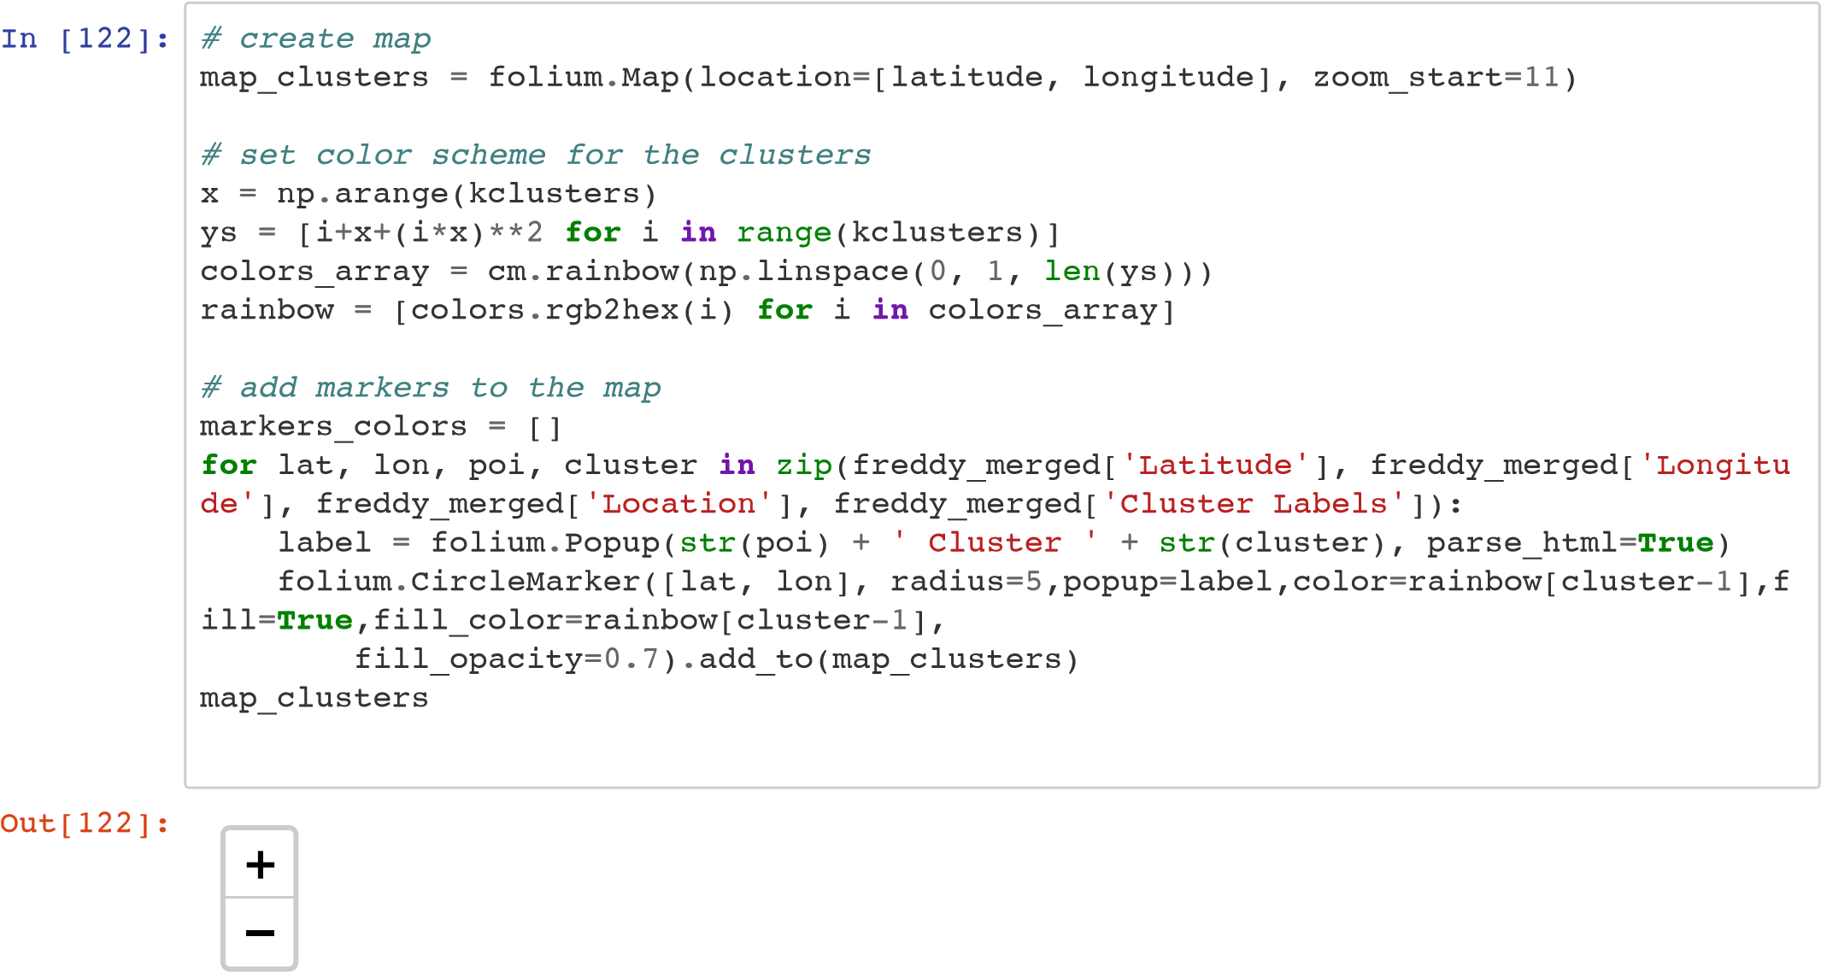

[Leaflet (http://leafletjs.com)](http://leafletjs.com/)

In [ ]:

1. Knowledge Park 45.931143 -66.652700
2. Fredericton Hill 45.948512 -66.656045
3. Nashwaaksis 45.983382 -66.644856
4. University of New Brunswick 45.948121 -66.641406
5. Devon 45.968802 -66.622738
6. New Maryland 45.892795 -66.683673
7. Marysville 45.978913 -66.589491
8. Skyline Acres 45.931827 -66.640339
9. Hanwell 45.902315 -66.755113
10. Downtown 45.958327 -66.647211

    **Add location markers to map** 